**National University of Computer & Emerging Sciences**

**Karachi Campus**



Project Report

Hospital Management System

**Course Teacher:**

**Sir Zain Ul- Hassan**

**Group Members:**

**Zaid Bin Shahab 19K-1512**

**Muhammad Ali 19K-0331**

**Saud Ahmed Abbasi 19K-0229**

1 Overview 5

2 Abstract 5

3 Introduction 5

4 Project Essentials Part#01: Connection string 6

5 Project Essentials Part#02: Base Setup Overview 7

5.1 Essential component: ApplicationDbContext 7

5.2 Default page 7

5.3 Collections used in various programs 9

5.3.1 Ambulance Collection 9

5.3.2 Appointment Collection 10

5.3.3 Doctor Collection 10

5.3.4 Schedule Collection 11

5.3.5 Prescription Collection 11

5.3.6 Collection of Collections 12

5.4 Bootstrap .css files 13

6 Main Program 14

6.1 Home page 14

6.1.1 Services 14

6.1.2 Comments left by patients 14

6.2 Registration 16

6.3 Roles 17

6.3.1 The Admin Role 17

6.3.1.1 Department 18

6.3.1.1.1 List Department 18

6.3.1.1.2 Add Department 19

6.3.1.1.3 Edit Department 20

6.3.1.1.4 Database Entries 20

6.3.1.2 Doctors 21

6.3.1.2.1 List of Doctors 21

6.3.1.2.2 Add Doctor 22

6.3.1.2.3 Edit Doctor 24

6.3.1.2.4 Database Entries 25

6.3.1.3 Patients 25

6.3.1.3.1 List of Patients 25

6.3.1.3.2 Edit Patients 26

6.3.1.3.3 Database Entries 27

6.3.1.4 Schedules 27

6.3.1.4.1 Add Schedules 28

6.3.1.4.3 Edit Schedules 29

6.3.1.4.3 List of Schedules 30

6.3.1.4.4 Database Entries 30

6.3.1.5 Appointments 30

6.3.1.5.1 Add Appointments 30

6.3.1.5.2 Edit Appointments 32

6.3.1.5.3 Active Appointments 33

6.3.1.5.4 Pending Appointments 33

6.3.1.5.5 Database Entries 33

6.3.1.6 Complaints 33

6.3.1.6.1 List of Complaints 33

6.3.1.6.2 Database Entries 34

6.3.1.6 Medicines 34

6.3.1.6.1 List of Medicines 34

6.3.1.6.2 Add Medicine 35

6.3.1.6.3 Edit Medicine 36

6.3.1.6.4 Database Entries 36

6.3.1.7 Ambulances 37

6.3.1.7.1 List of Ambulances 37

6.3.1.7.2 Add Ambulance 37

6.3.1.7.3 List of Ambulance Drivers 38

6.3.1.7.4 Add Ambulance Drivers 39

6.3.1.7.5 Edit Ambulance 40

6.3.1.7.6 Edit Ambulance Drivers 41

6.3.1.7.7 Database Entries 41

6.3.1.8 Announcements 42

6.3.1.7.1 List of Announcements 42

6.3.1.7.2 Add Announcements 43

6.3.1.7.3 Edit Announcements 43

6.3.1.7.3 Database Values 44

6.3.2 The Doctor 44

6.3.2.1 Prescriptions 45

6.3.2.1.1 List Prescriptions 45

6.3.2.1.2 Add Prescriptions 45

6.3.2.1.2 Edit Prescriptions 47

6.3.2.1.3 List of Prescriptions 48

6.3.2.1.4 Database Entries 49

6.3.2.2 Schedule 49

6.3.2.2.1 Your Schedule 49

6.3.2.2.2 Edit Schedule 50

6.3.2.2.3 Database Entries 50

6.3.2.3 Appointments 50

6.3.2.3.1 Active Appointments 51

6.3.2.3.2 Pending Appointments 51

6.3.2.3.3 Add Appointments 51

6.3.2.3.4 Edit Appointments 53

6.3.2.3.5 Database Entries 53

6.3.3 The Patient 54

6.3.3.1 Doctors 54

6.3.3.1.1 Available Doctors 54

6.3.3.2 Appointment 54

6.3.3.2.1 Your Appointments 55

6.3.3.2.2 Request Appointment 55

6.3.3.2.3 Edit Appointment 56

6.3.3.2.4 Database Values 57

6.3.3.3 Prescription 57

6.3.3.3.1 Your Prescriptions 57

6.3.3.3.2 Prescriptions View 58

6.3.3.3.3 Database Values 58

6.3.3.4 Complaints 58

6.3.3.4.1 List of Complaints 59

6.3.3.4.2 Add Complaint 59

6.3.3.4.3 Edit Complaint 59

6.3.3.4.4 Database Values 60

7 Middleware 61

7.1 Original WebService.asmx file 61

7.2 Understanding the Run Method 62

7.2.1 Method Signature Example#01 62

7.2.2 Method Signature Example#02 62

8 Conclusion 65

9 References 66

# 1 Overview

Humans have a complex and sophisticated anatomical structure that comprises of millions of intricate smaller detailed functions. As sickness and health became a topic for research, so to did the study of the human body. With the advent and progression of science and technology, medical science has become an entirely separate emerging field of science. Therefore, the health sector that is responsible for the conditions that ail the human body aim to provide the best possible medical facilities to the common individual.[1][5]

# 2 Abstract

Rapid growth in the Information Communication Technologies (ICT) sector compels business and service delivery models to grow as efficiently as possible. [3] The Hospital Management System (HMS) is designed to provide the benefits of streamlined operations, control over complex management operations, provide superior patient customer care, improve efficiency, and enhance the administration activity potential. [1] It is backed by offline support that is reliable and dependable. The Hospital Management System is reliant on database, object orient and networking techniques.[1] Healthcare systems that have international status in health need to comply to specific Healthcare Insurance Portability & Accountability Act (HIPAA) standards which is the norm for the management of medical records and the privacy for patient information in the Healthcare industry.[4]

# 3 Introduction

Populations are skyrocketing at ever-increasing rates rapidly every year, and health care is become more and more of a commonplace necessity. The hospital is the place where patients can be treated by specialized staff and equipment. Hospital consists of professional physicians, surgeons, nurses and receptionist management. It is a place where people who are unwell can go for medical check-ups and treatment. [2]

Hospital workflows operate over a cycle of 24 hours. That is why hospitals require an efficient management system. As studied by Tousaaint (2015), hospitals cannot function optimally without better management systems. [2] That is why a good functioning hospital requires an appropriate medical management system that is able to provide the most applicable healthcare facilities available to them. [3]

# 4 Project Essentials Part#01: Connection string

Open the Web.config file:

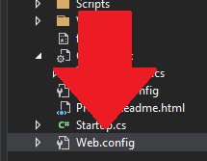

To find:

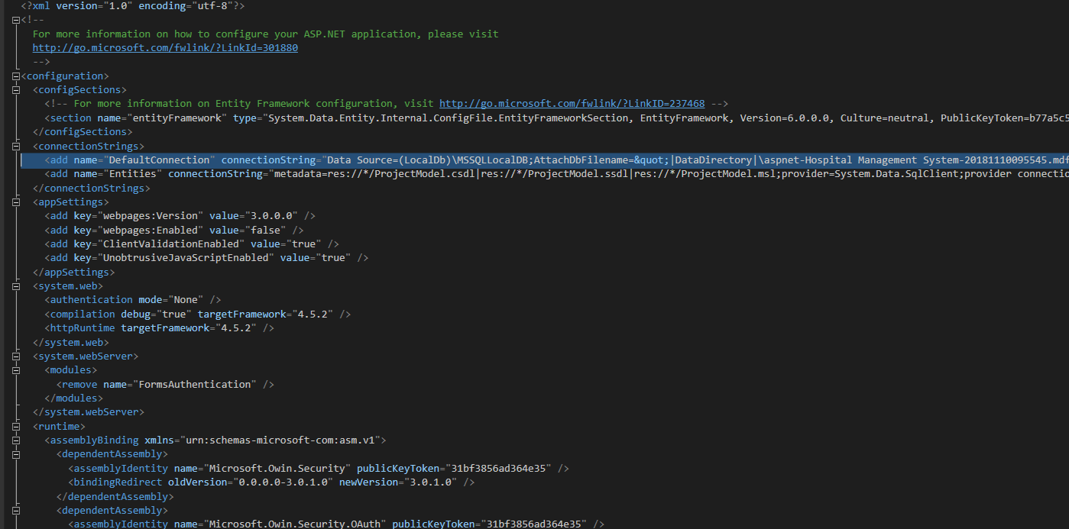

<add name="DefaultConnection" connectionString="Data Source=(LocalDb)\MSSQLLocalDB;AttachDbFilename=&quot;|DataDirectory|\aspnet-Hospital Management System-20181110095545.mdf&quot;;Initial Catalog=&quot;aspnet-Hospital Management System-20181110095545&quot;;Integrated Security=True" providerName="System.Data.SqlClient" />

Adjust the connection string value appropriately to run the program

# 5 Project Essentials Part#02: Base Setup Overview

## 5.1 Essential component: ApplicationDbContext

Used for Authorized CRUD operations  


Can be used for specifying unique operations such as flagging/restricting requirements for logging in, for the username it does not have to be Alphanumeric (“Saud” is enough, doesn’t have to be “Saud_123” etc)

The password is also restricted, needs to have a length of 6, require a non-letter, require both upper and lower case (We don’t need “Saud_123” for username, but we can use it for our password)

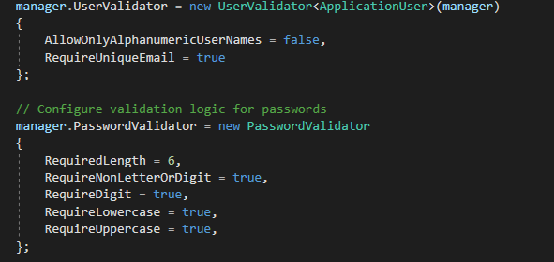

## 5.2 Default page

The default opening page is our Home/Index

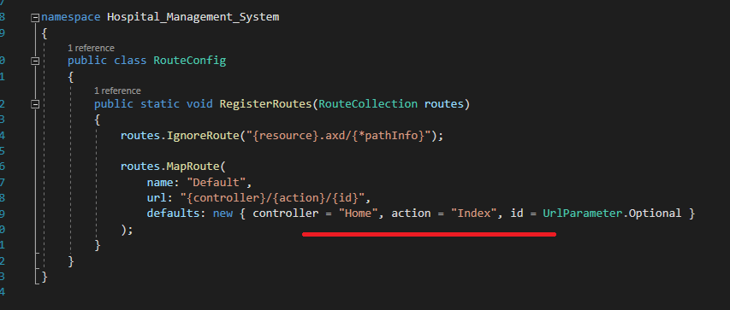

Auto Generated code for the authorization validation portion, the only part that we need to personally define is the PathString for the “Account/Login” where we are deploying the login state:

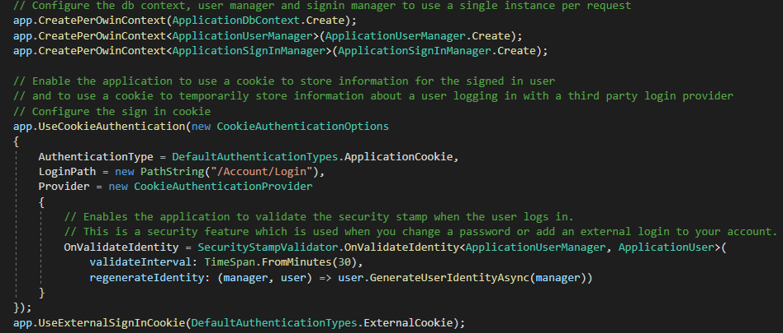

## 5.3 Collections used in various programs

### 5.3.1 Ambulance Collection

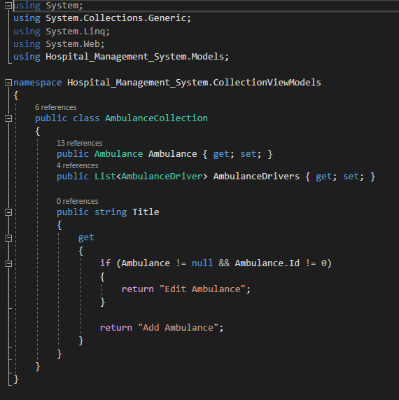

### 5.3.2 Appointment Collection

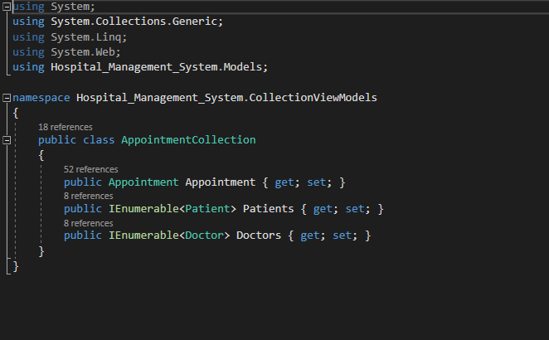

### 5.3.3 Doctor Collection

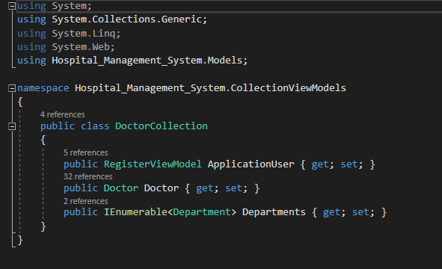

### 5.3.4 Schedule Collection

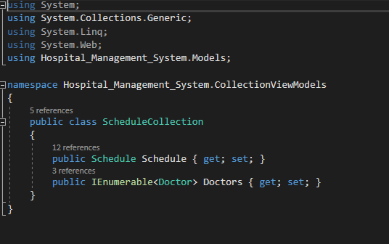

### 5.3.5 Prescription Collection

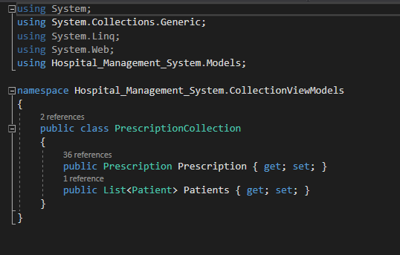

### 5.3.6 Collection of Collections

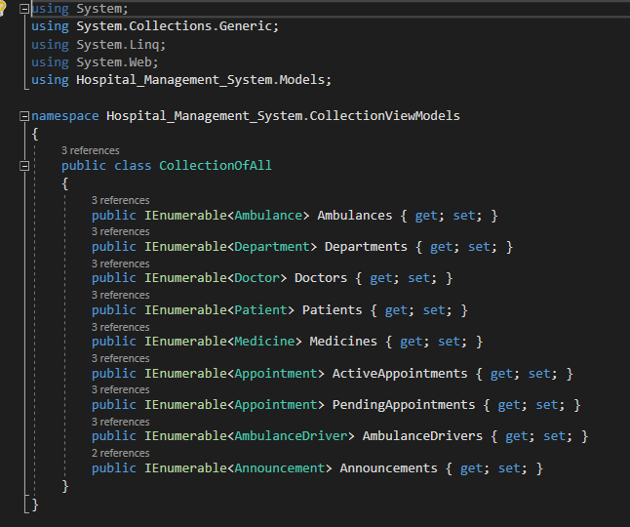

## 5.4 Bootstrap .css files

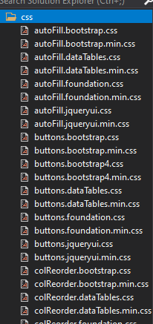

# 6 Main Program

## 6.1 Home page

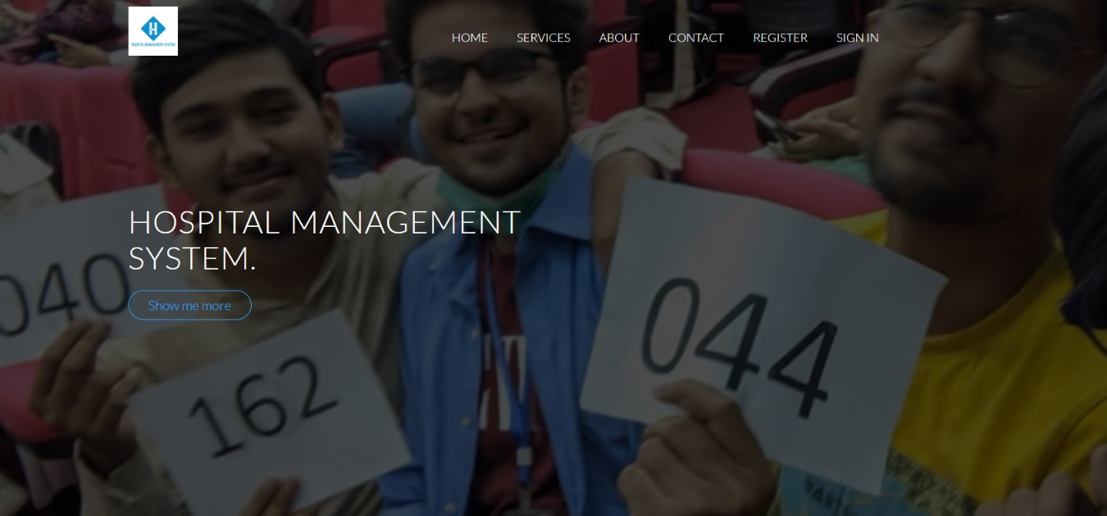

### 6.1.1 Services

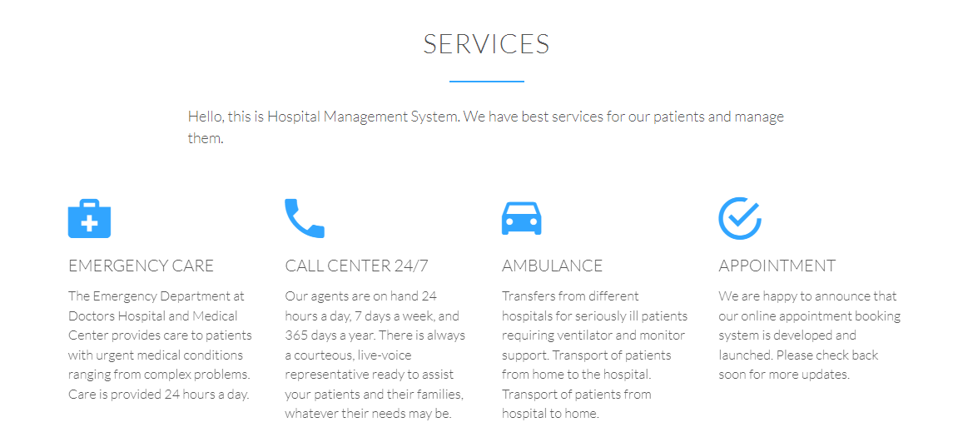

6.1.2 Comments left by patients



## 6.2 Registration

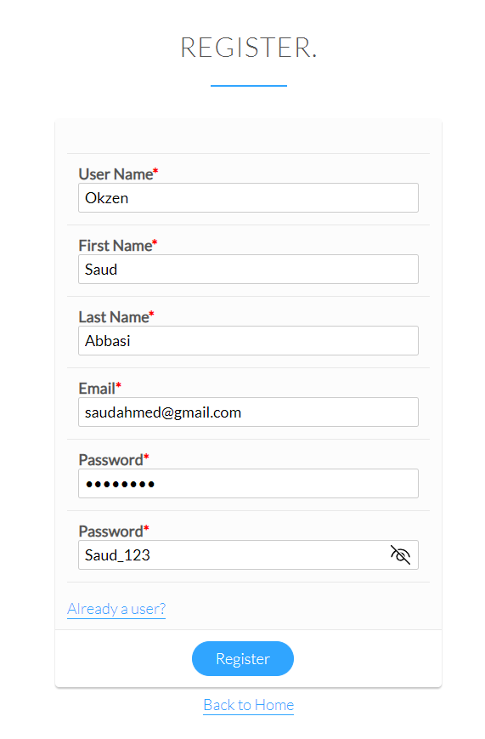

The registration simply inserts the user details and their respective role, the UserManager specifically uses ApplicationUser consisting of all the relevant details and the password, whereas the role is used to different the admin, doctor and the patient.

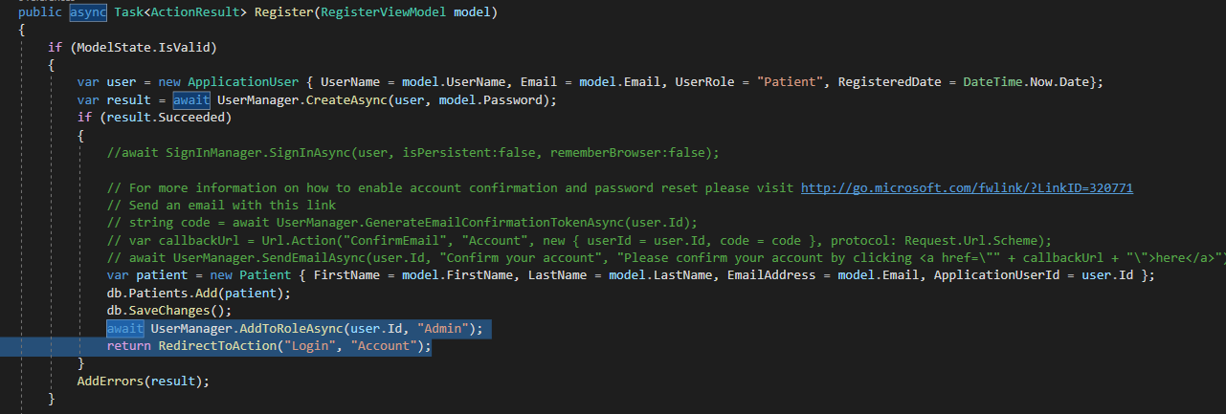

## 6.3 Roles

Here are all the key roles available in the program

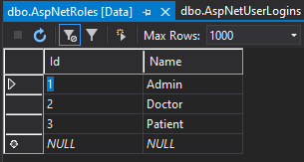

### 6.3.1 The Admin Role

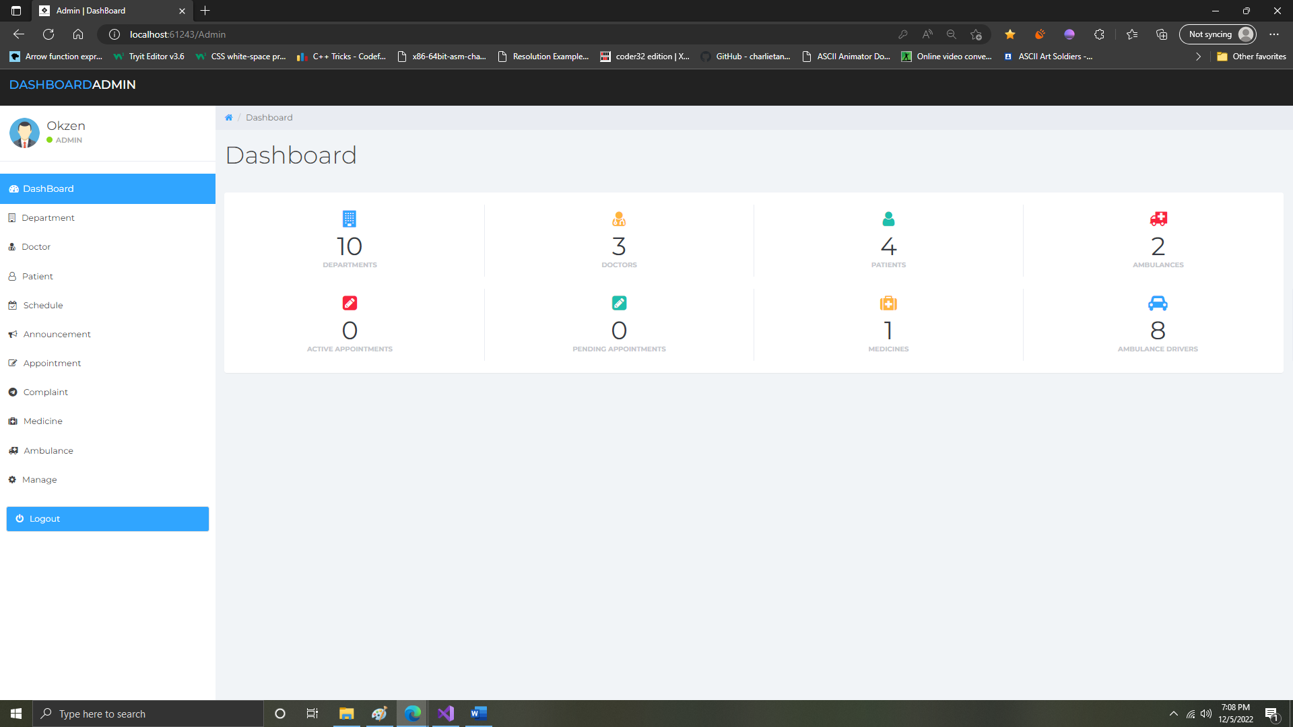

Db sets for retrieving all the relevant lists for each relevant category in the admins panel.

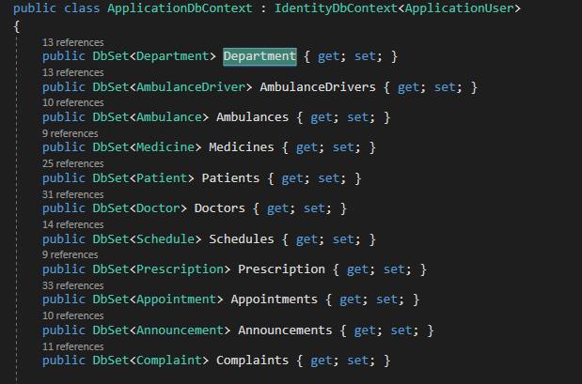

#### 6.3.1.1 Department

Here the admin can set the department in which the doctor will exercise their field of expertise.

##### 6.3.1.1.1 List Department

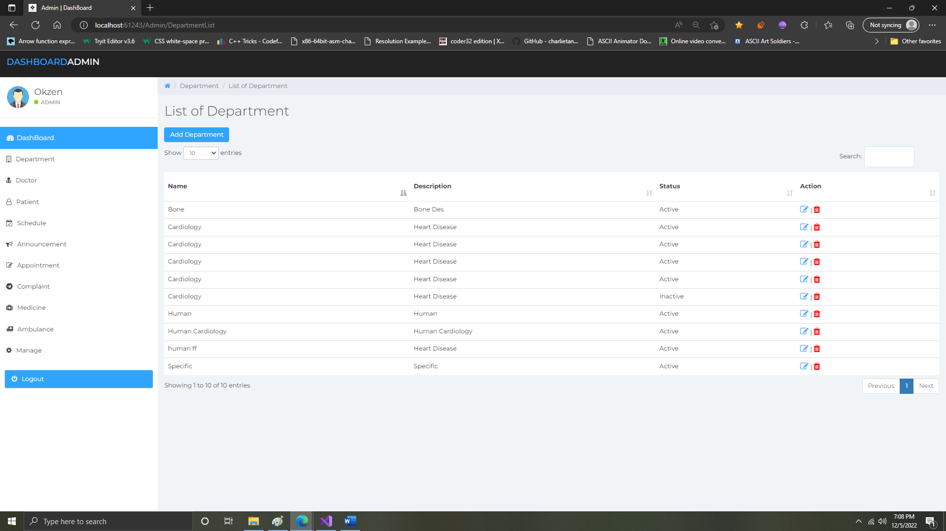

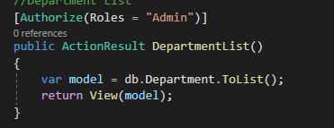

##### 6.3.1.1.2 Add Department

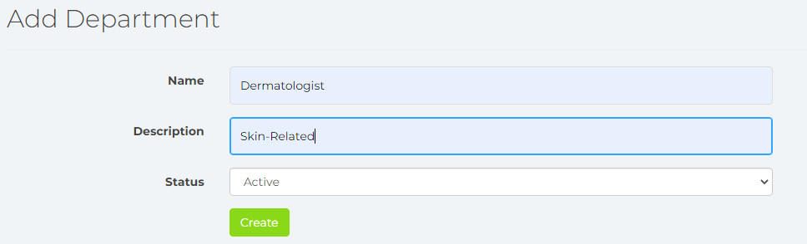

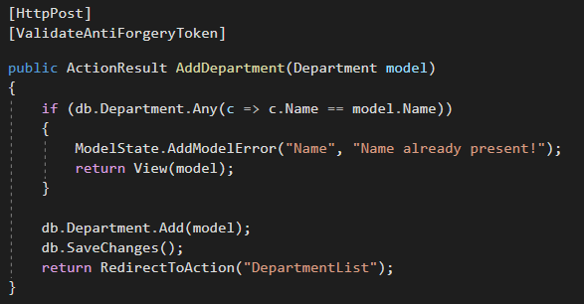

##### 6.3.1.1.3 Edit Department

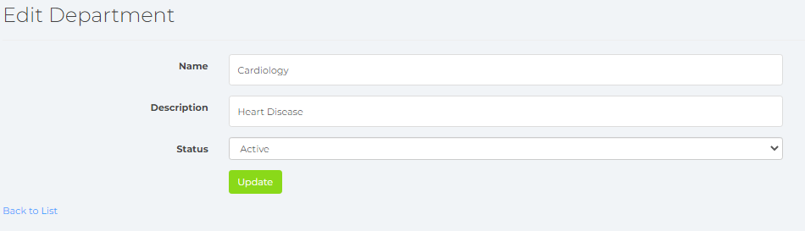

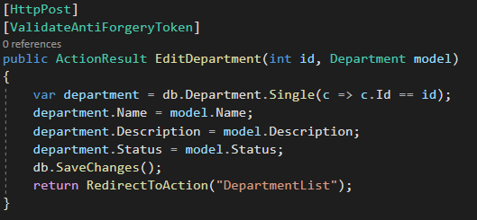

##### 6.3.1.1.4 Database Entries

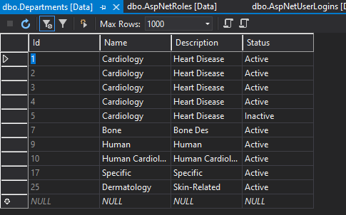

#### 6.3.1.2 Doctors

Here the admin can enter and edit all the relevant Doctor information including details for the Doctor user account that will be used.

##### 6.3.1.2.1 List of Doctors

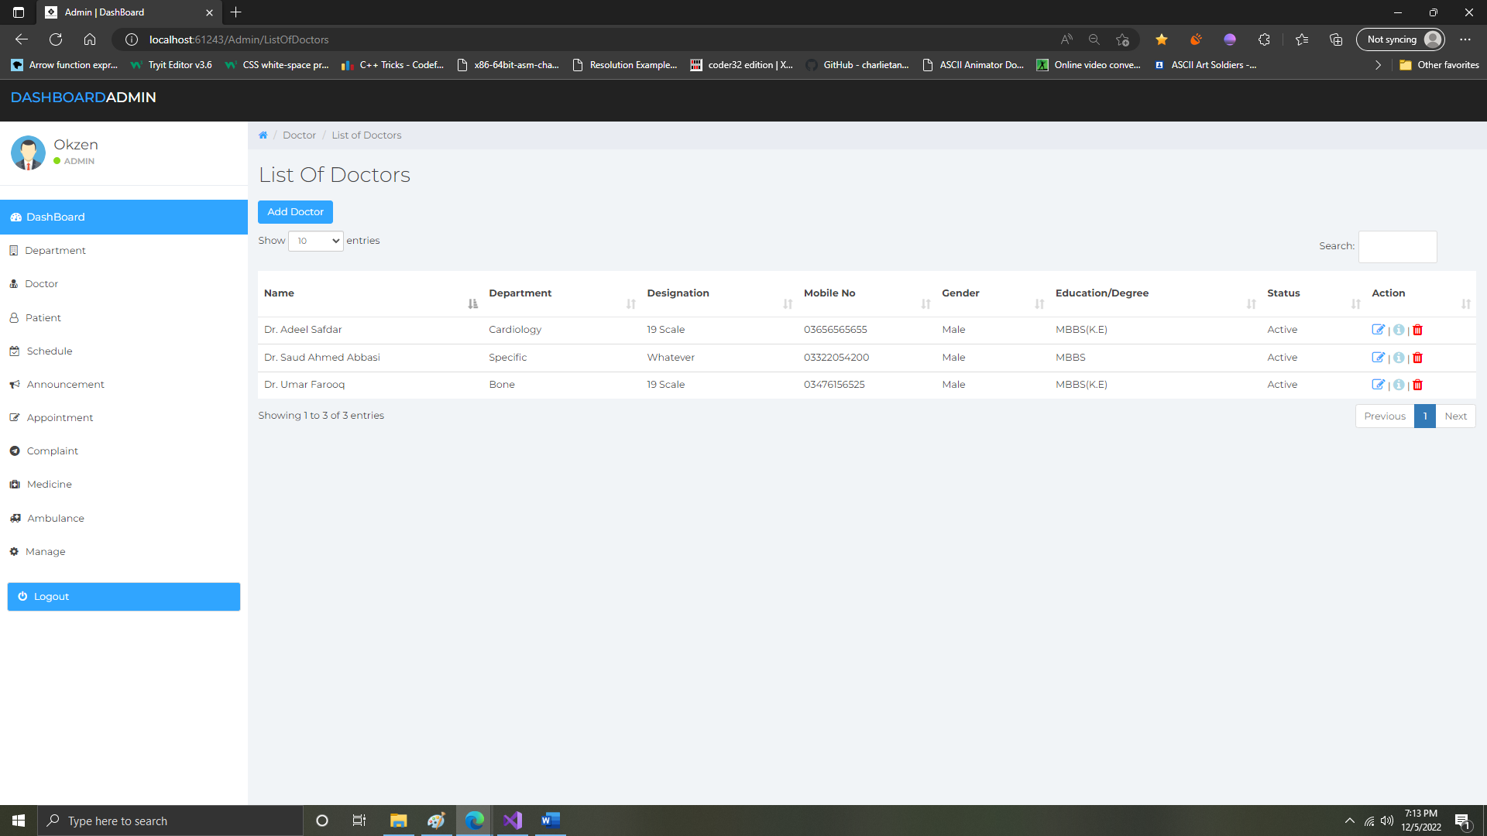

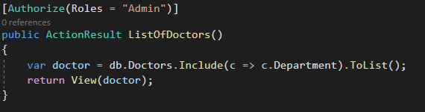

##### 6.3.1.2.2 Add Doctor

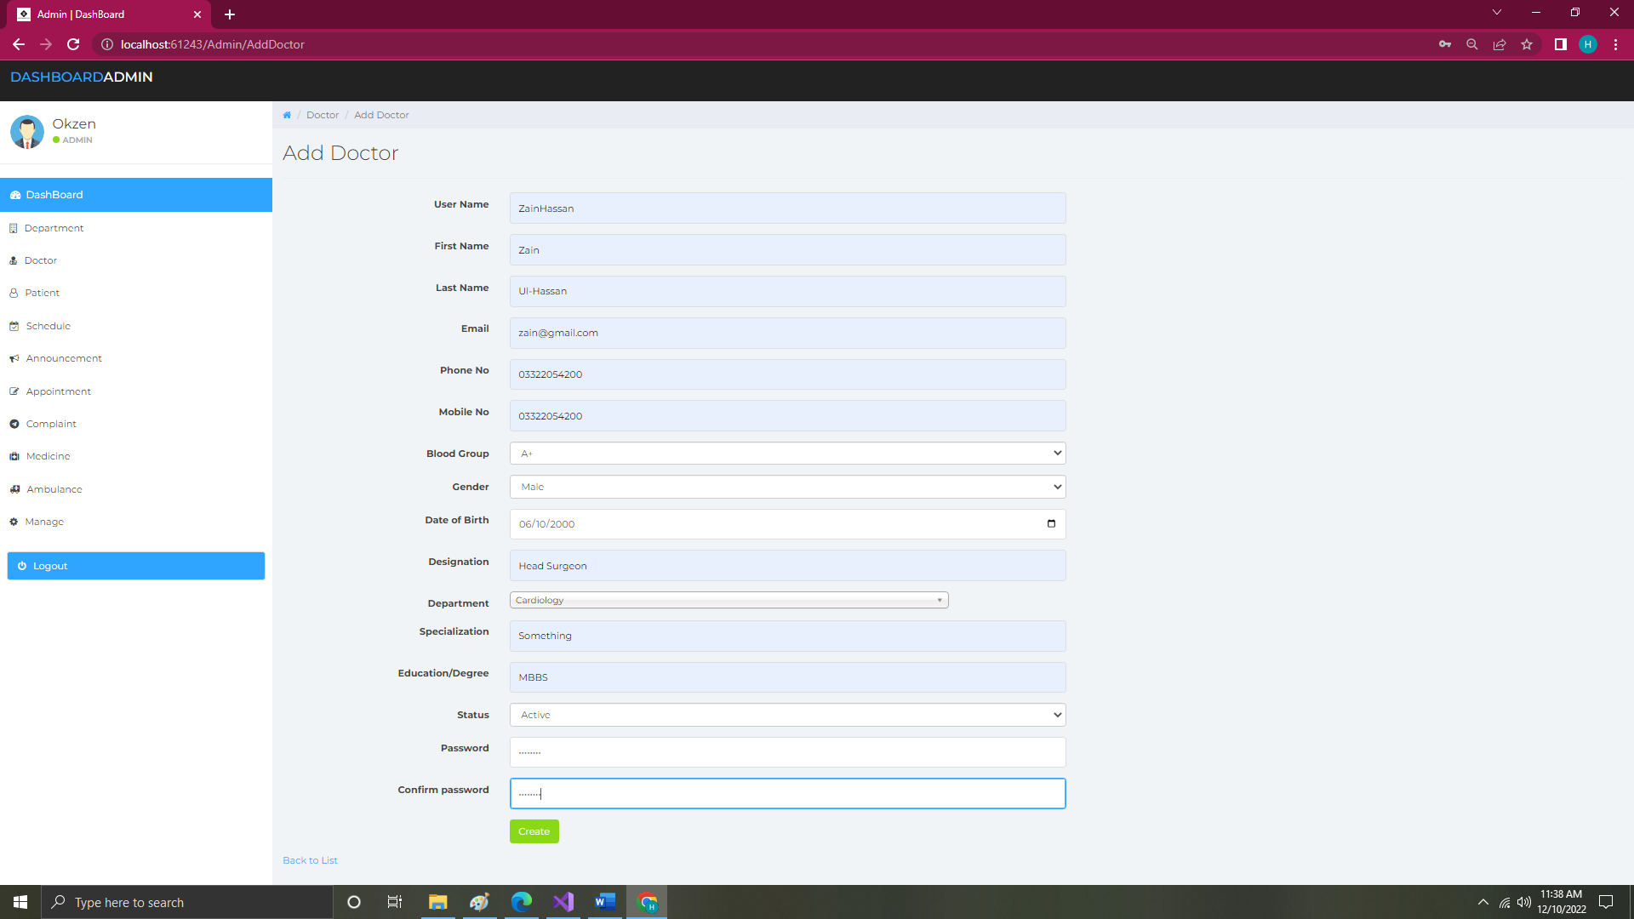

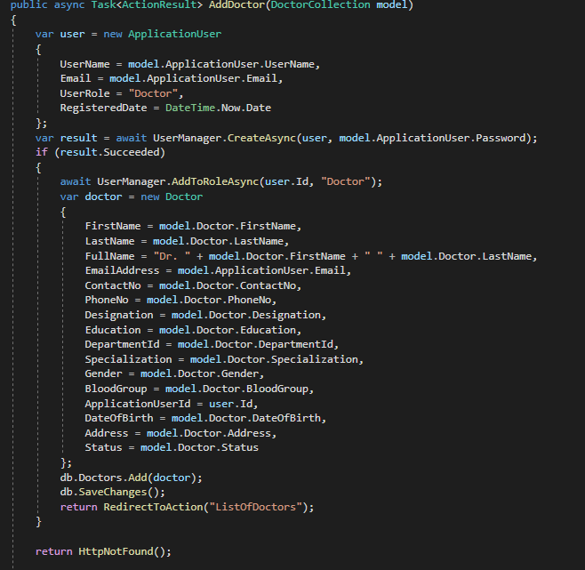

##### 6.3.1.2.3 Edit Doctor

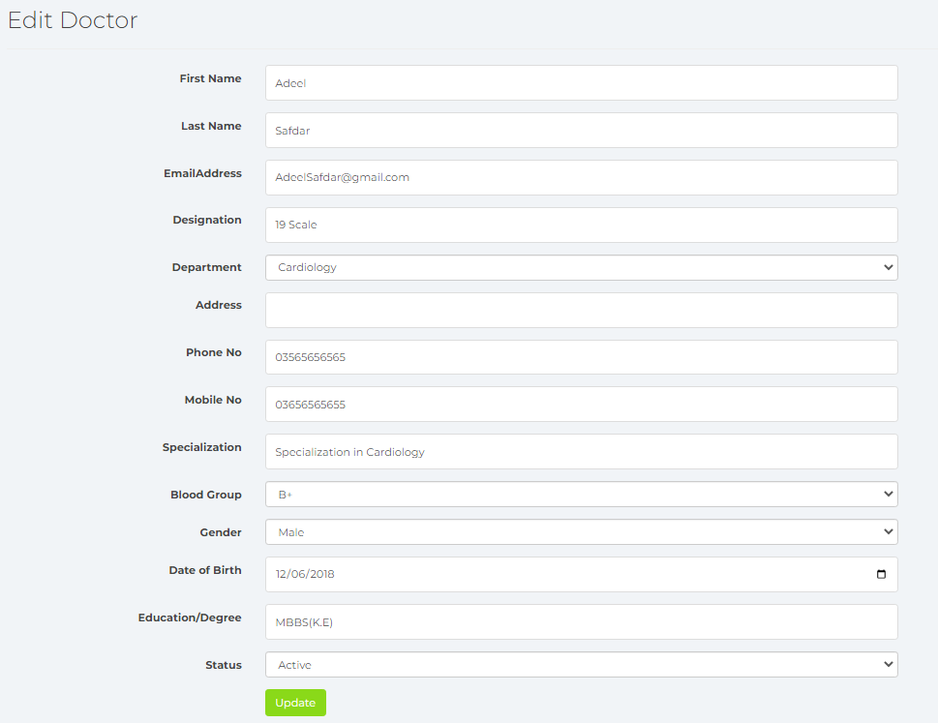

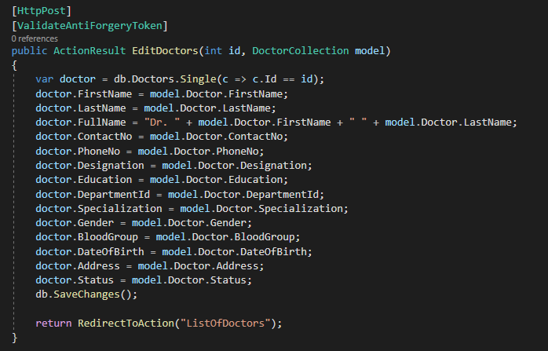

##### 6.3.1.2.4 Database Entries

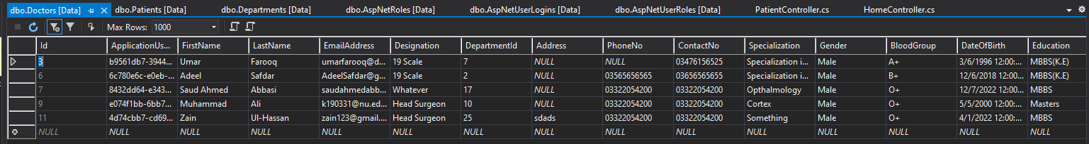

#### 6.3.1.3 Patients

Here the admin can view, remove, edit the patient’s data accordingly.

##### 6.3.1.3.1 List of Patients

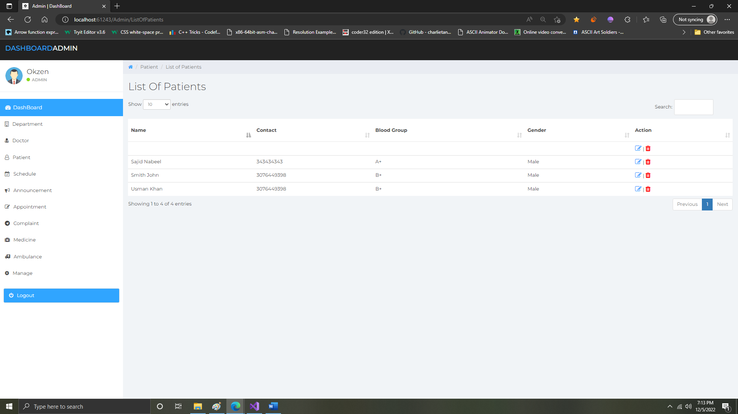

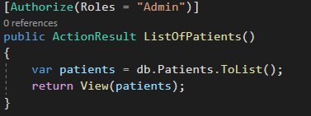

##### 6.3.1.3.2 Edit Patients

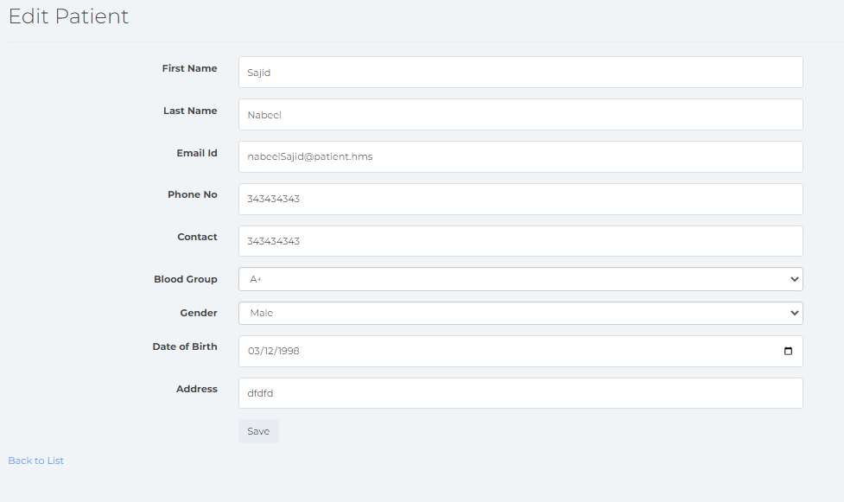

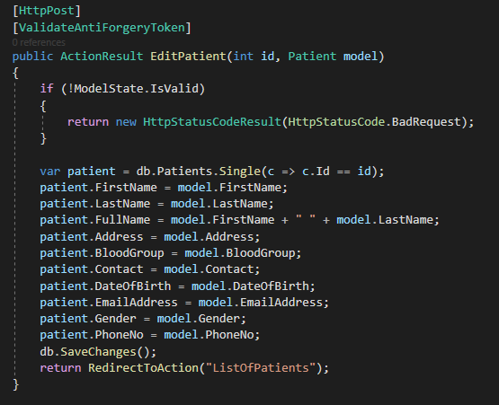

##### 6.3.1.3.3 Database Entries

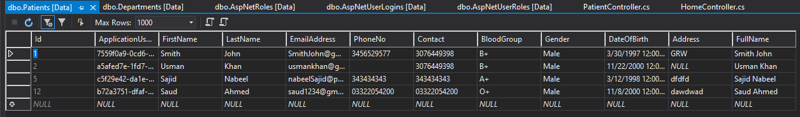

#### 6.3.1.4 Schedules

Here the admin can set the schedule for the doctor for his free hours for giving consultation to patients.

##### 6.3.1.4.1 Add Schedules

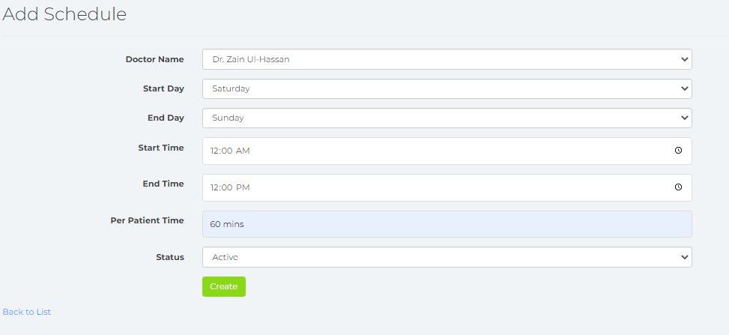

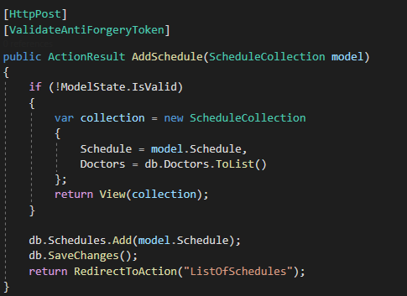

##### 6.3.1.4.3 Edit Schedules

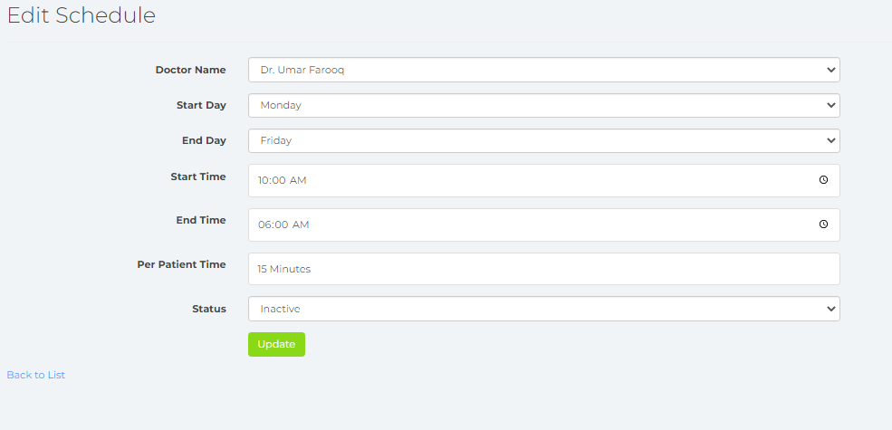

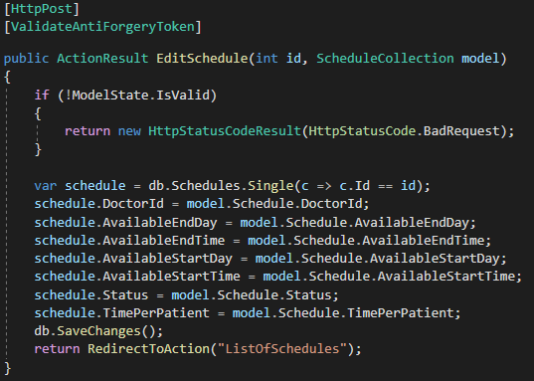

##### 6.3.1.4.3 List of Schedules

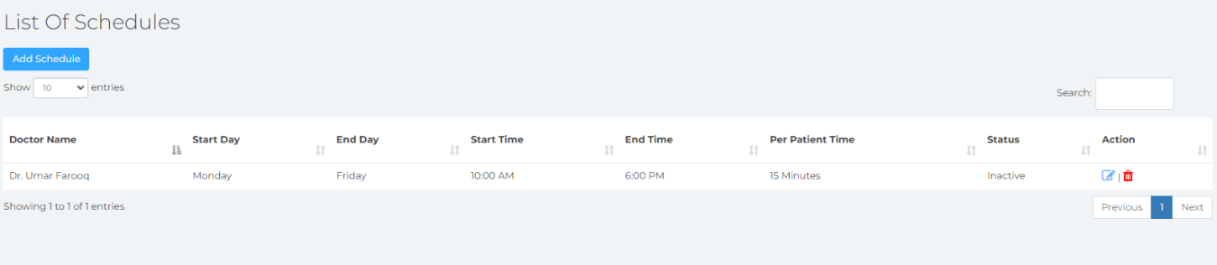

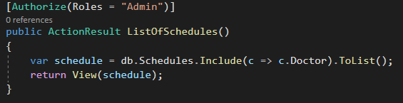

##### 6.3.1.4.4 Database Entries

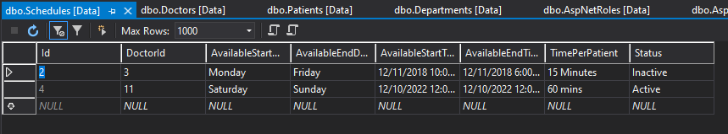

#### 6.3.1.5 Appointments

Here the admin can set appointment timings for doctors to correspond to possible customer booking hours.

##### 6.3.1.5.1 Add Appointments

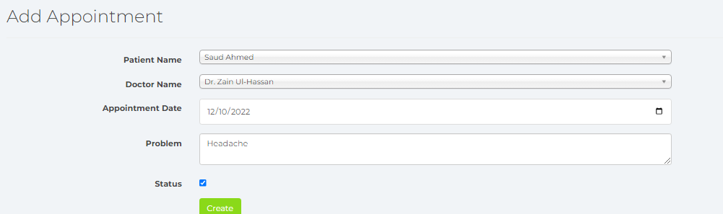

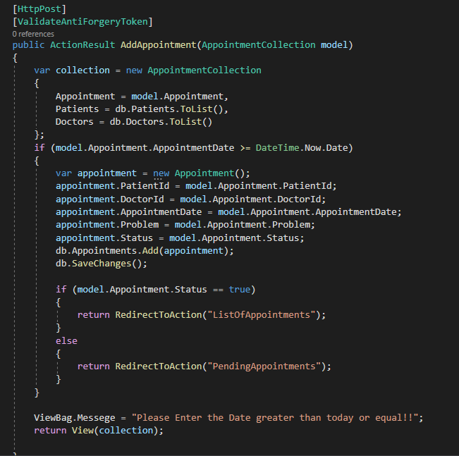

##### 6.3.1.5.2 Edit Appointments

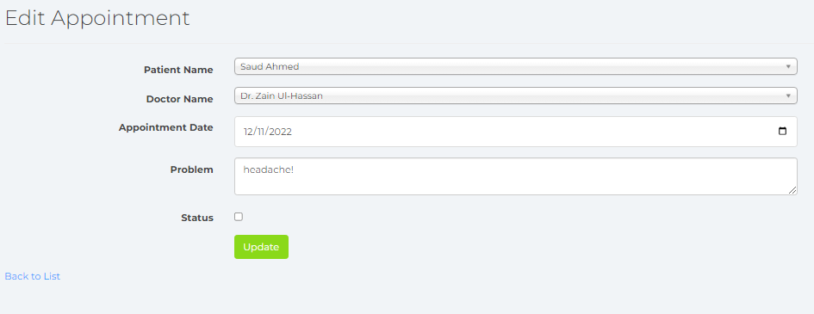

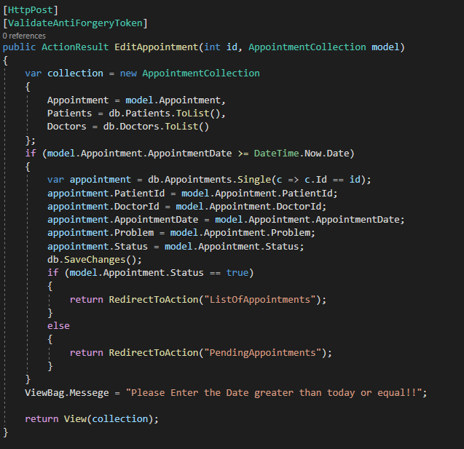

##### 6.3.1.5.3 Active Appointments

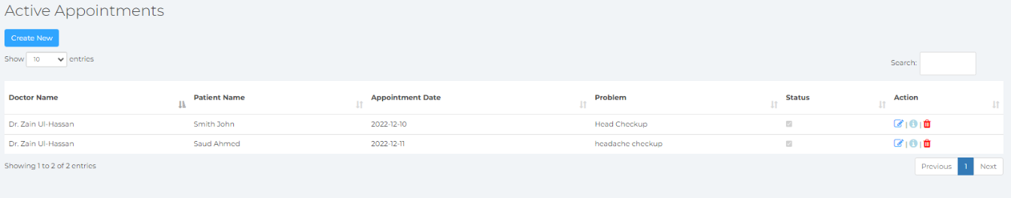

##### 6.3.1.5.4 Pending Appointments

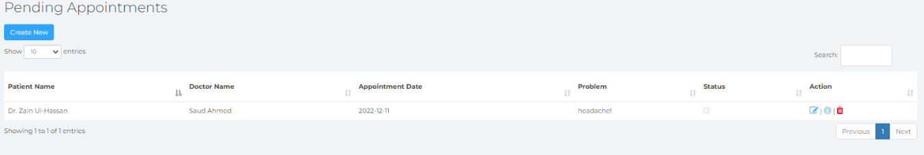

##### 6.3.1.5.5 Database Entries

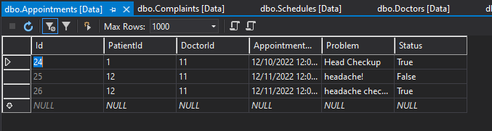

#### 6.3.1.6 Complaints

Here the admin can view and respond to all the complaints my the patients that have visited the hospital.

##### 6.3.1.6.1 List of Complaints

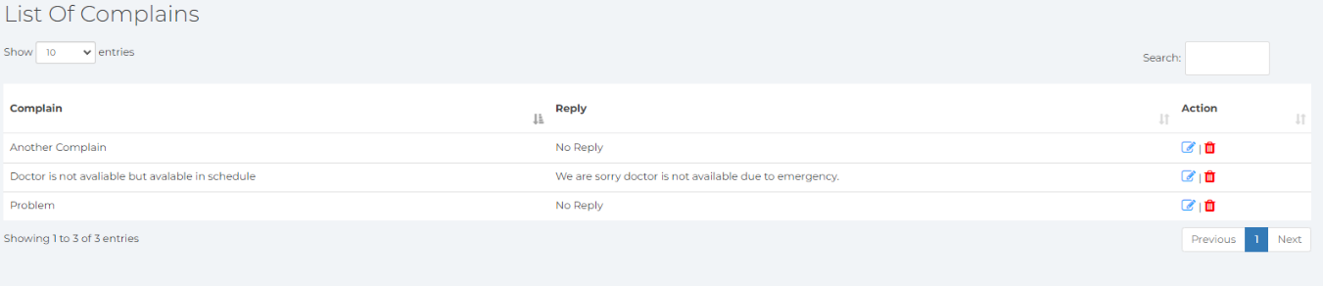

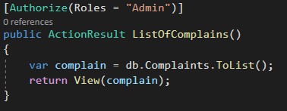

##### 6.3.1.6.2 Database Entries

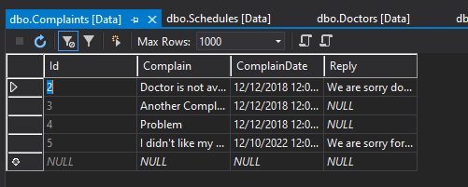

#### 6.3.1.6 Medicines

Here the admin can manage the pharmaceutical stock unit for the medicines, in reality the medicinal unit would be under a completely separate medicinal management sector, but for simplicities sake we have given the admin the privilege in this small establishment, where the stock tallies are outsourced numbers.

##### 6.3.1.6.1 List of Medicines

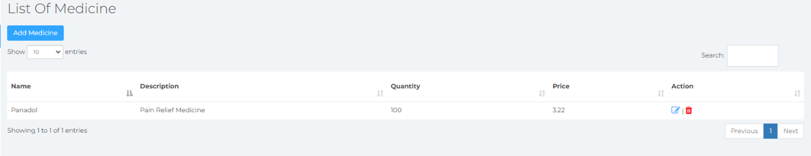

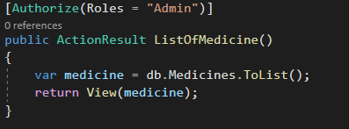

##### 6.3.1.6.2 Add Medicine

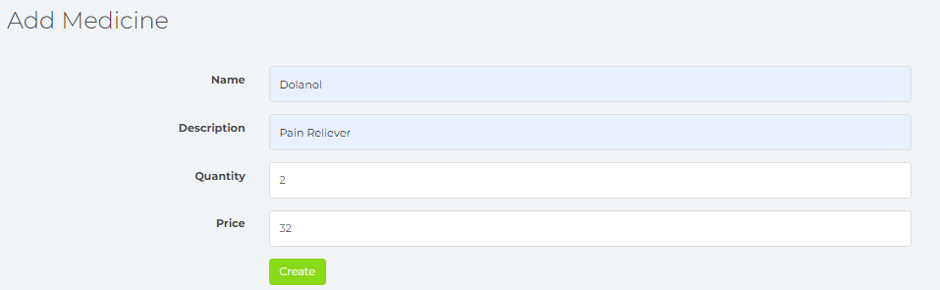

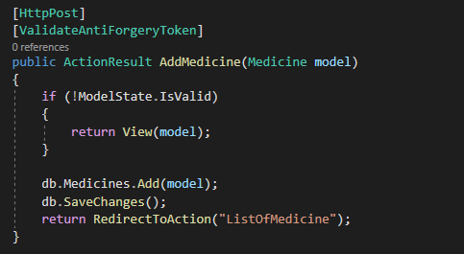

##### 6.3.1.6.3 Edit Medicine

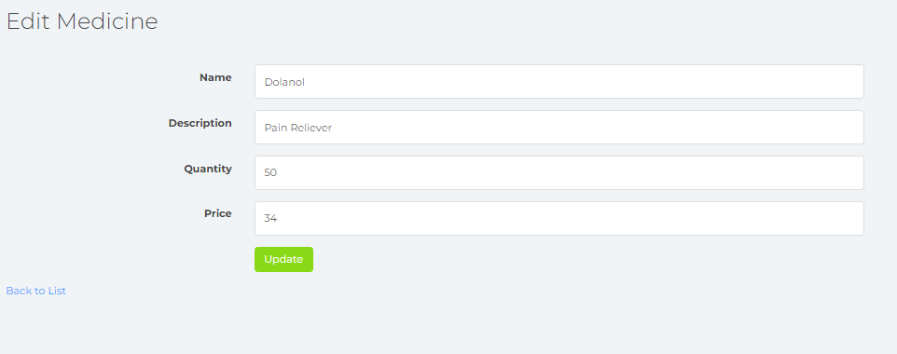

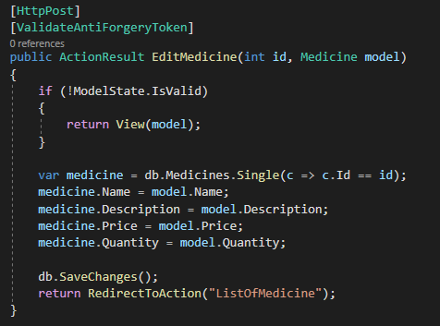

##### 6.3.1.6.4 Database Entries

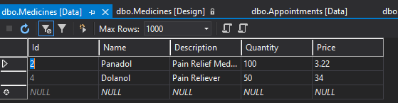

#### 6.3.1.7 Ambulances

Here the admin can store all the ambulance information such as the number plate and other essentials.

##### 6.3.1.7.1 List of Ambulances

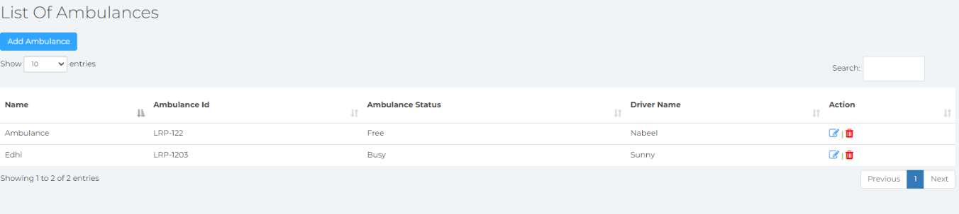

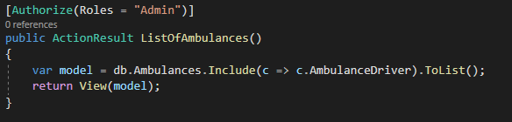

##### 6.3.1.7.2 Add Ambulance

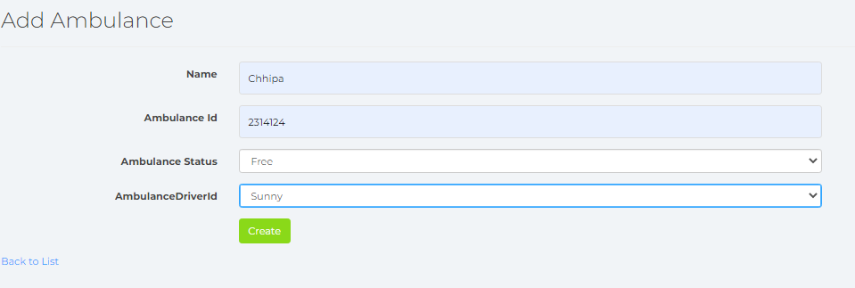

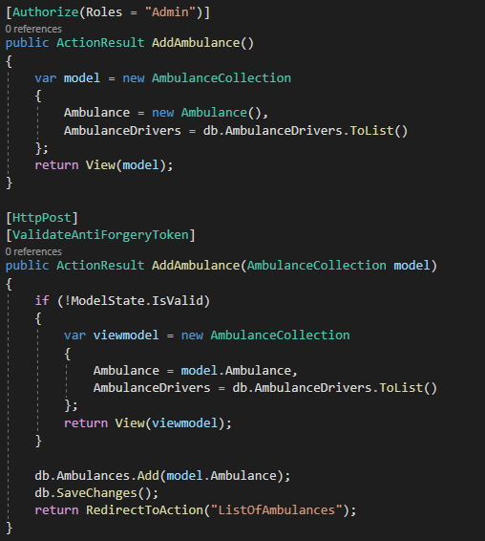

Here the admin can store all the driver details incase of any emergencies or inconveniences that may be encountered.

##### 6.3.1.7.3 List of Ambulance Drivers

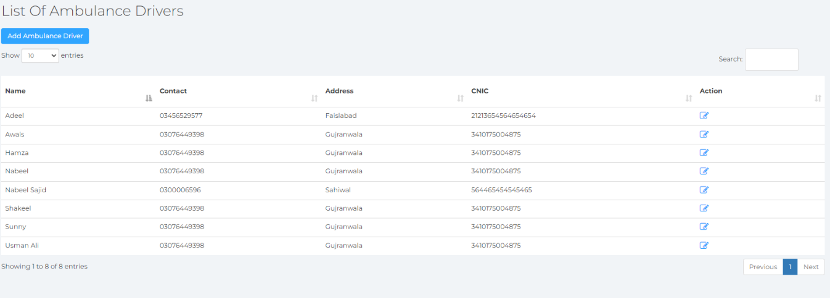

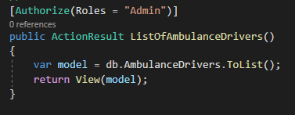

##### 6.3.1.7.4 Add Ambulance Drivers

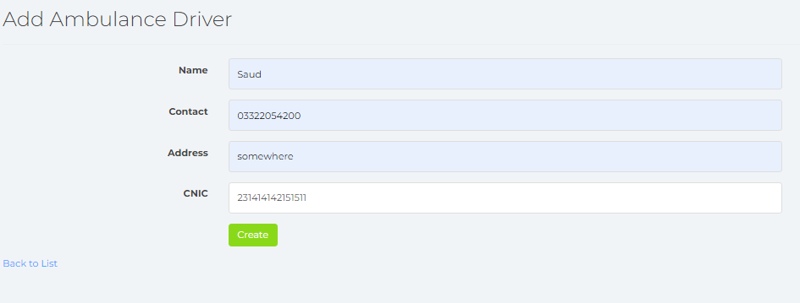

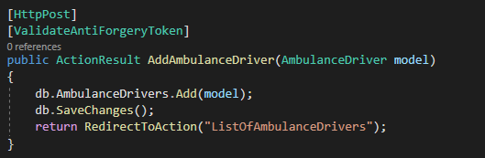

##### 6.3.1.7.5 Edit Ambulance

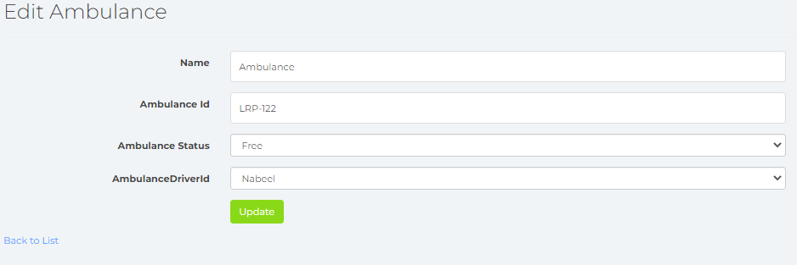

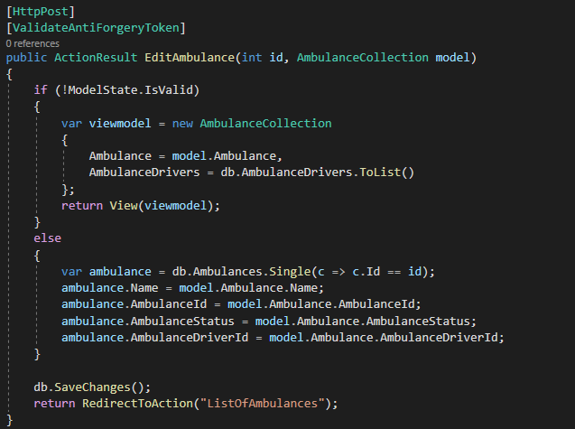

##### 6.3.1.7.6 Edit Ambulance Drivers

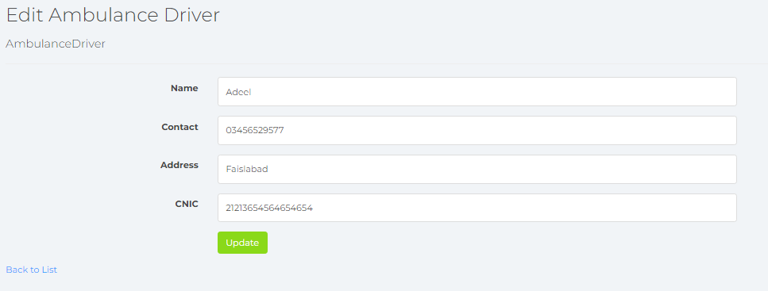

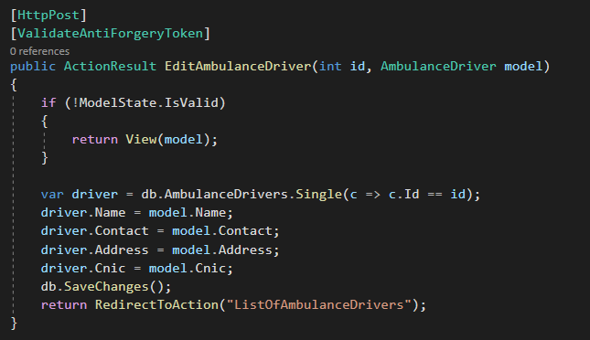

##### 6.3.1.7.7 Database Entries

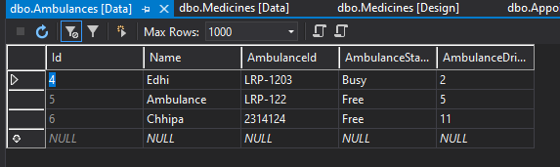

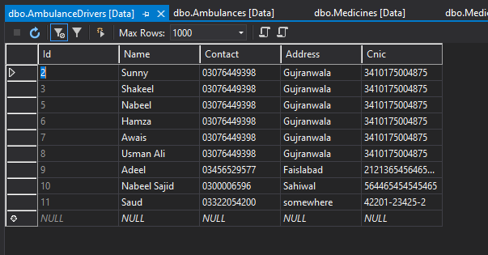

#### 6.3.1.8 Announcements

Here the admin can post announcements for either patients or doctors, incase of any emerging difficulties on-site, or possible security comprimse.

##### 6.3.1.7.1 List of Announcements

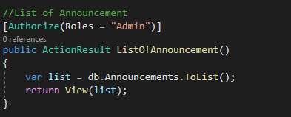

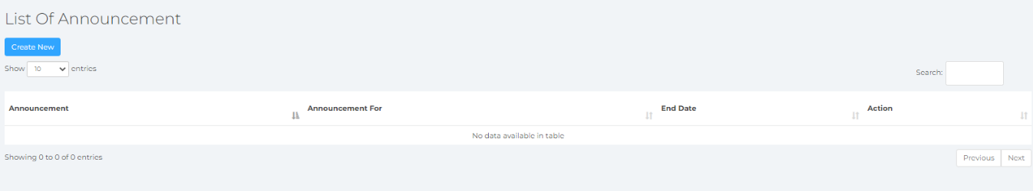

##### 6.3.1.7.2 Add Announcements

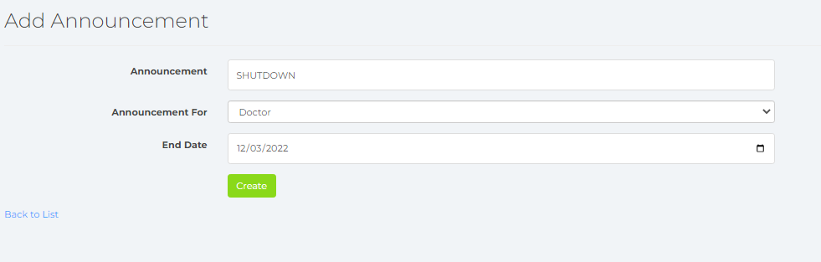

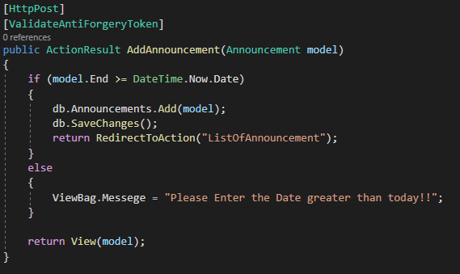

##### 6.3.1.7.3 Edit Announcements

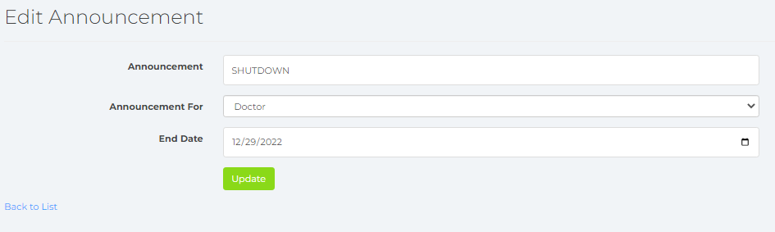

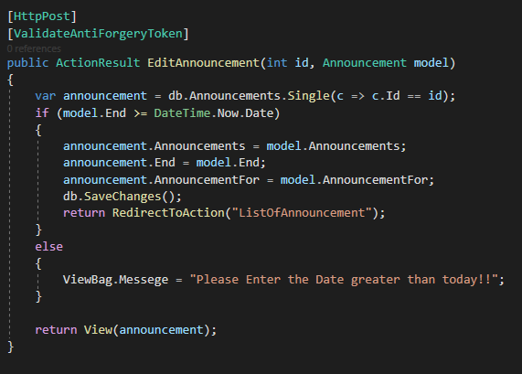

##### 6.3.1.7.3 Database Values

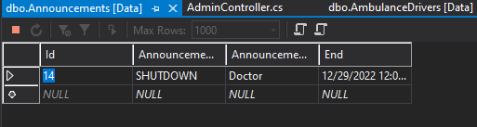

### 6.3.2 The Doctor

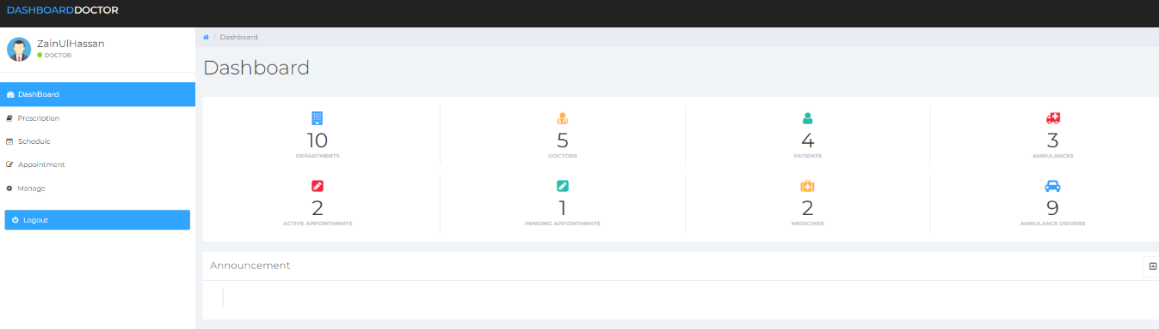

#### 6.3.2.1 Prescriptions

Here the doctor can prescribe the medicine and consumption timings for up to 7 slots for their patients.

##### 6.3.2.1.1 List Prescriptions

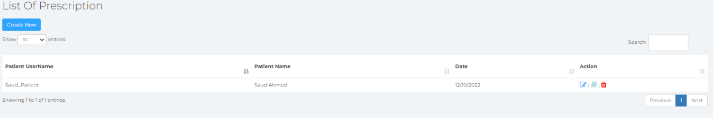

##### 6.3.2.1.2 Add Prescriptions

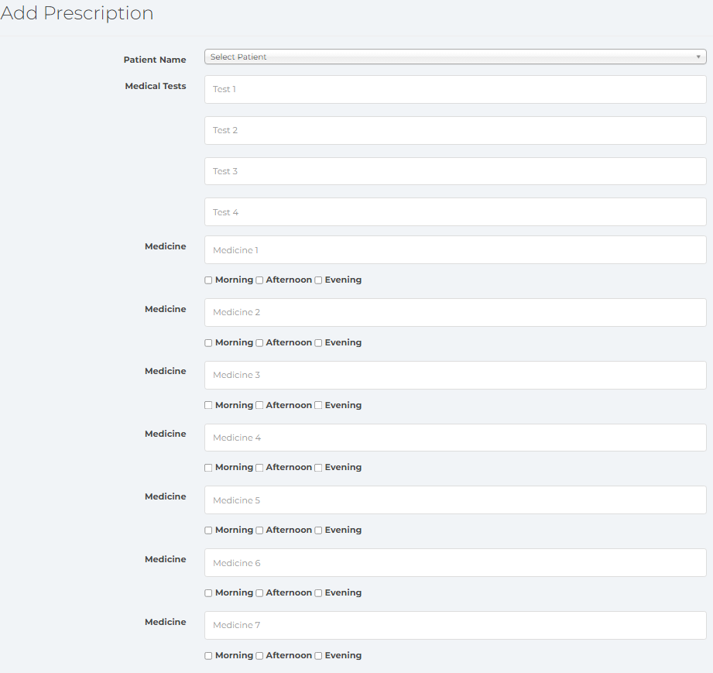

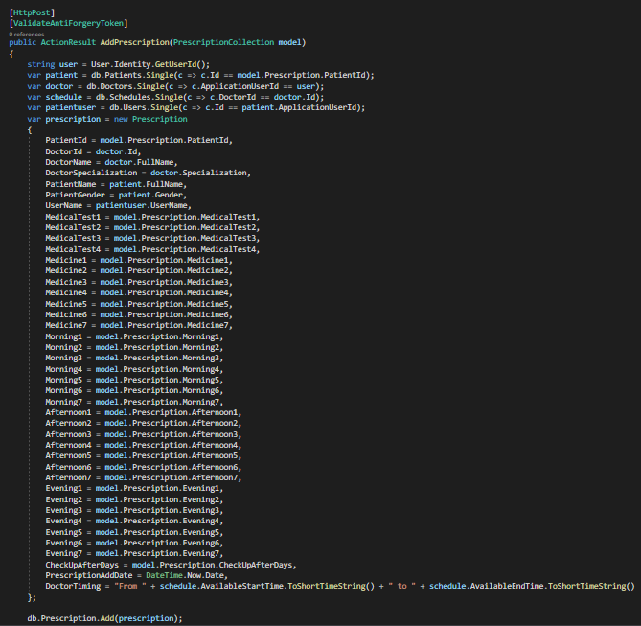

##### 6.3.2.1.2 Edit Prescriptions

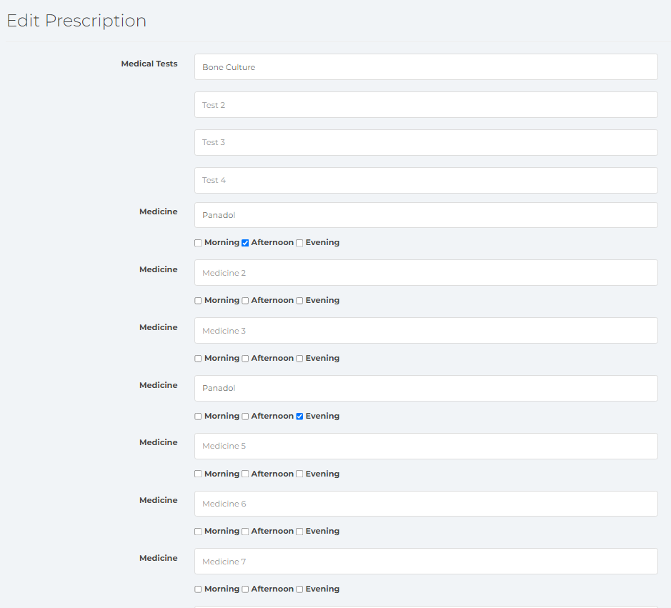

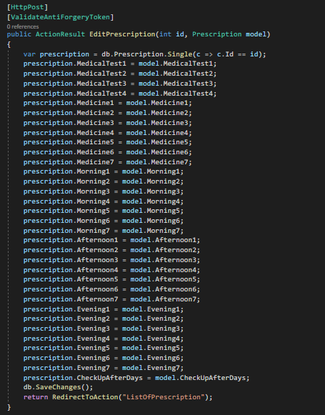

##### 6.3.2.1.3 List of Prescriptions

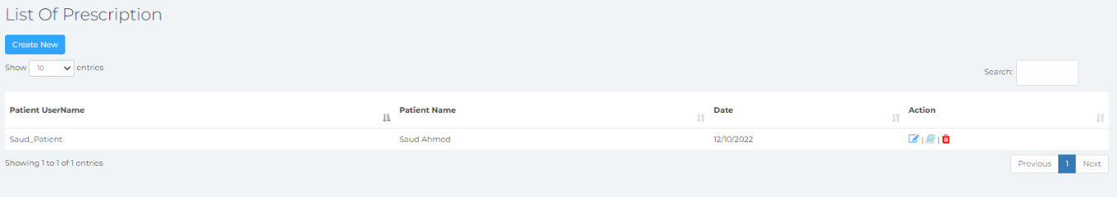

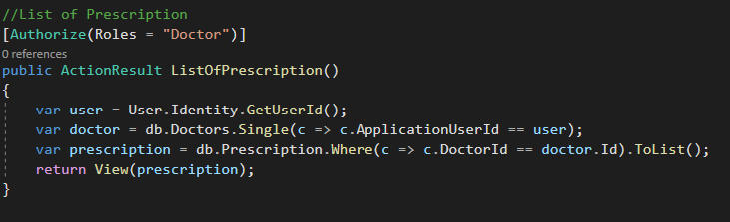

##### 6.3.2.1.4 Database Entries

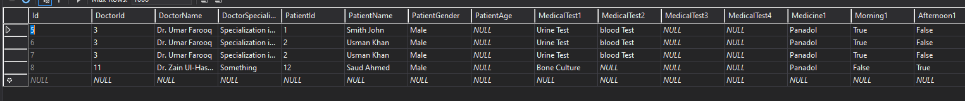

#### 6.3.2.2 Schedule

Here the doctor can view the schedule they’ve been provided by the admin, and make quality of life edits and consult with the admin later.

##### 6.3.2.2.1 Your Schedule

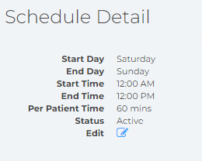

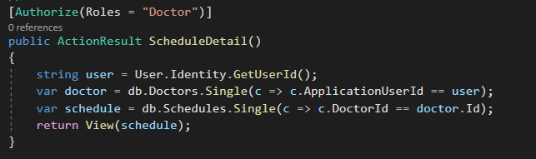

##### 6.3.2.2.2 Edit Schedule

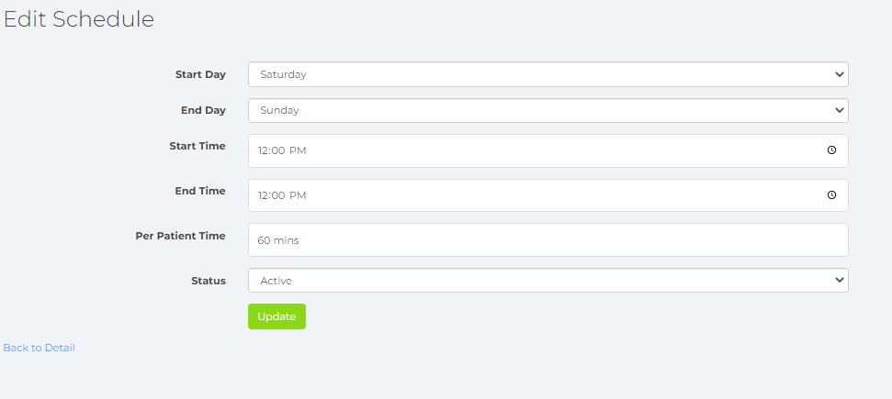

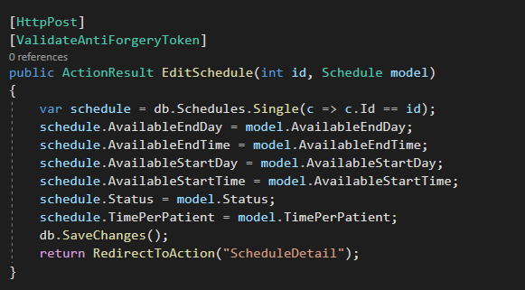

##### 6.3.2.2.3 Database Entries

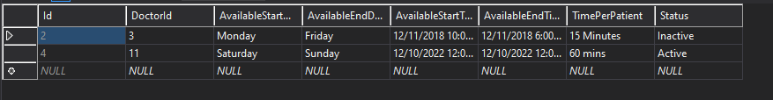

#### 6.3.2.3 Appointments

Here the admin can match their appointments with their patients.

##### 6.3.2.3.1 Active Appointments

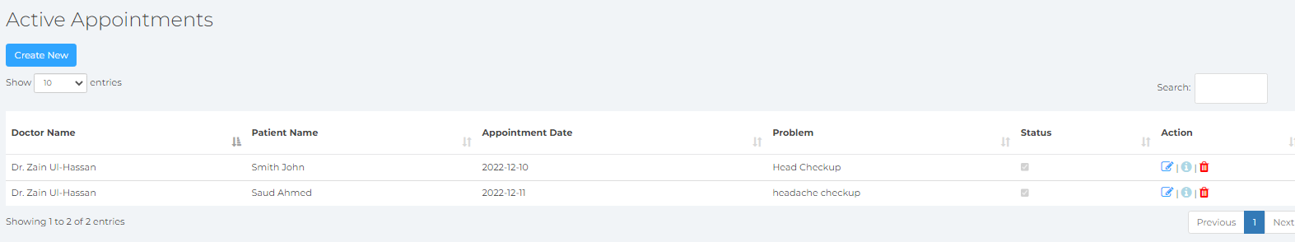

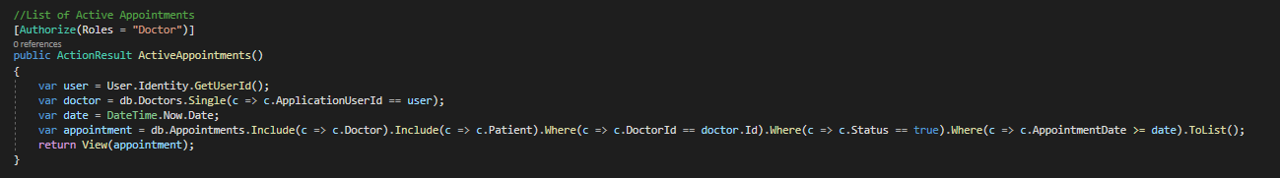

##### 6.3.2.3.2 Pending Appointments

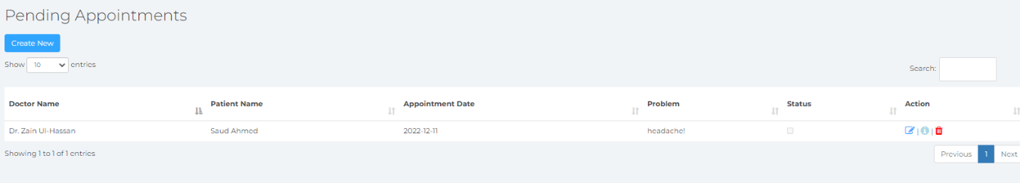

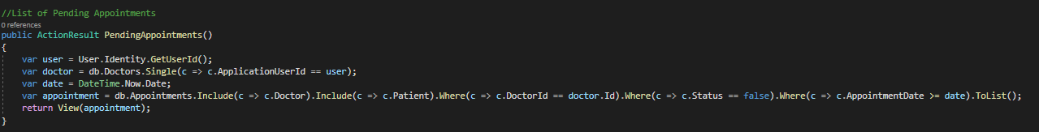

##### 6.3.2.3.3 Add Appointments

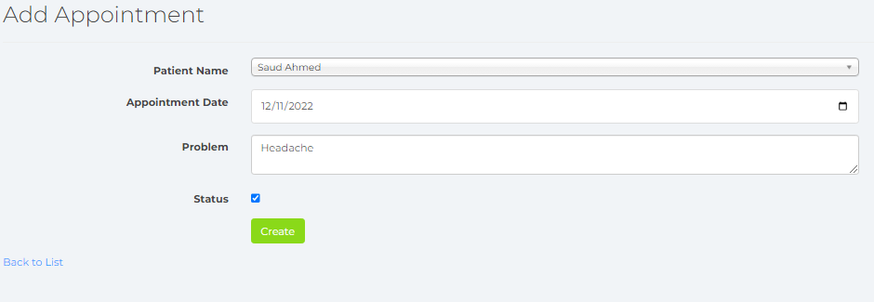

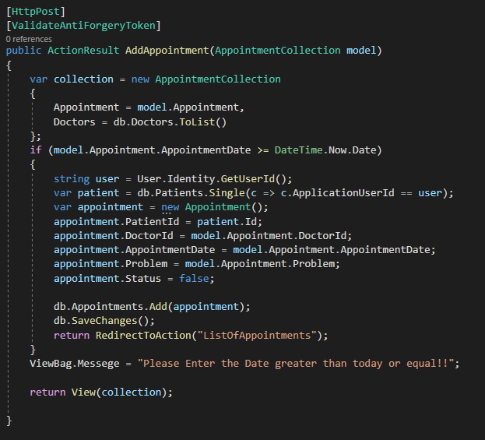

##### 6.3.2.3.4 Edit Appointments

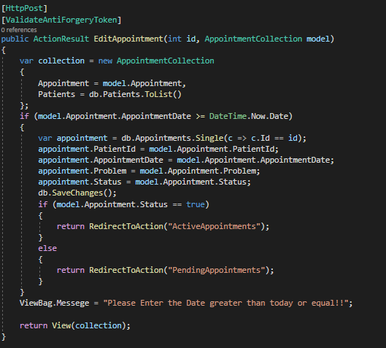

##### 6.3.2.3.5 Database Entries

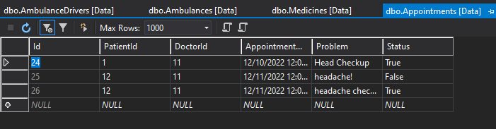

### 6.3.3 The Patient

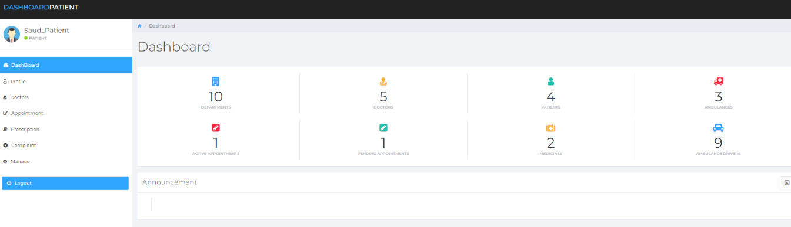

#### 6.3.3.1 Doctors

Here the patient can view all the doctors that are available at the site.

##### 6.3.3.1.1 Available Doctors

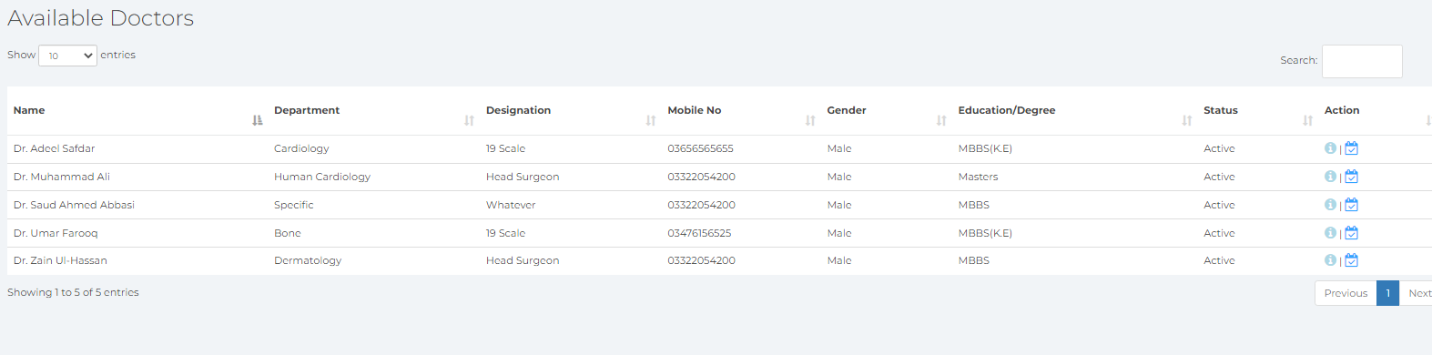

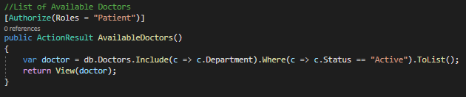

#### 6.3.3.2 Appointment

Here the patient can request a potential appointment with the doctor of their choice, given that they are available at the specific hours and belong to the specialization that is required to handle the case of the patient.

##### 6.3.3.2.1 Your Appointments

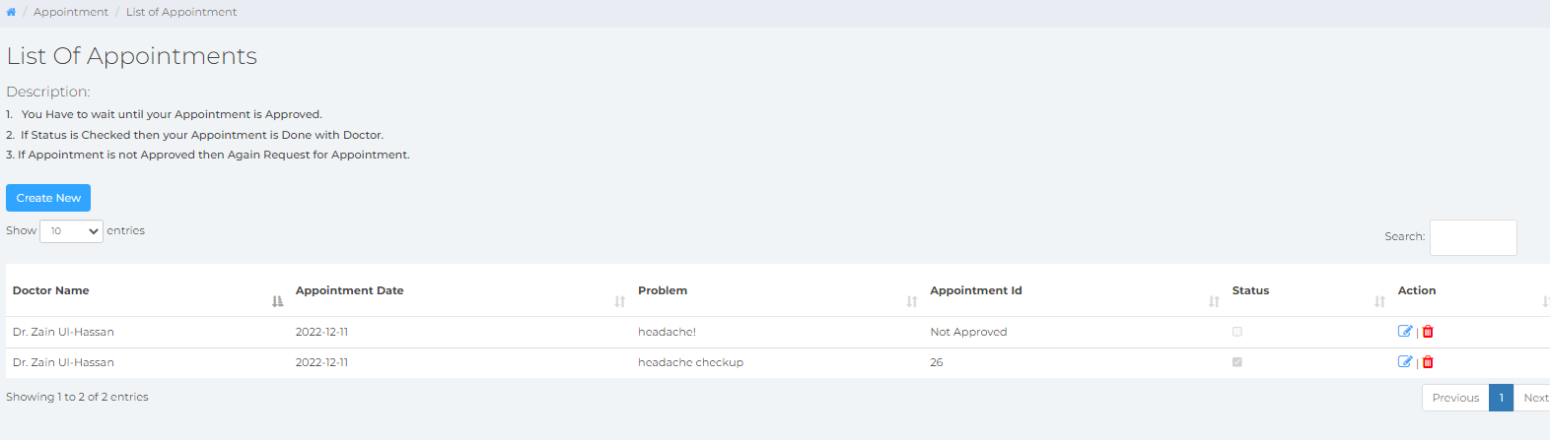

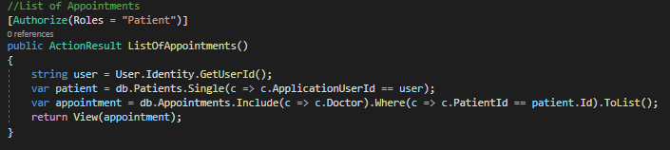

##### 6.3.3.2.2 Request Appointment

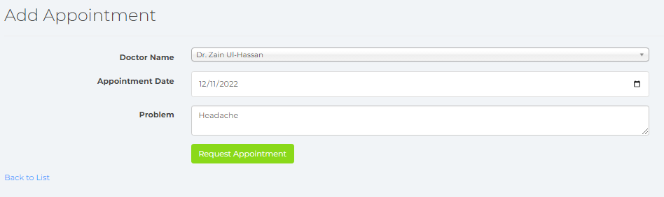

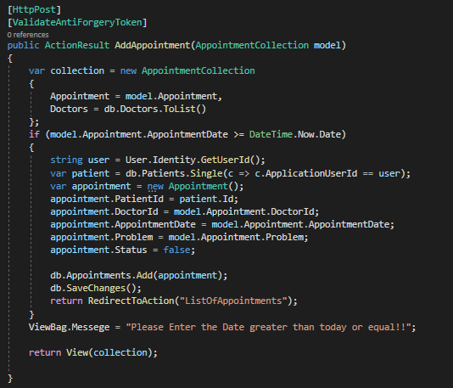

##### 6.3.3.2.3 Edit Appointment

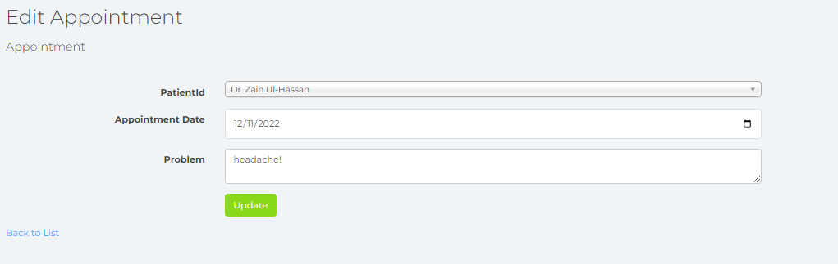

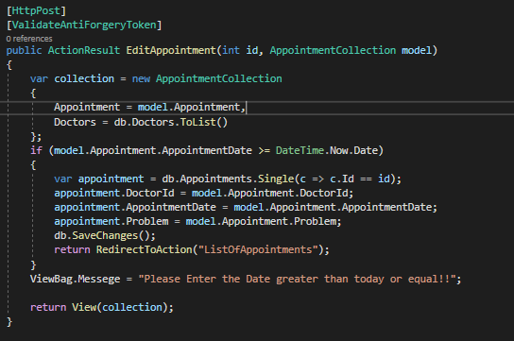

##### 6.3.3.2.4 Database Values



#### 6.3.3.3 Prescription

Here the patient can view the prescription prescribed by their designated doctor.

##### 6.3.3.3.1 Your Prescriptions

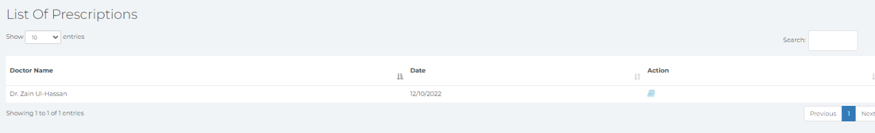

##### 6.3.3.3.2 Prescriptions View

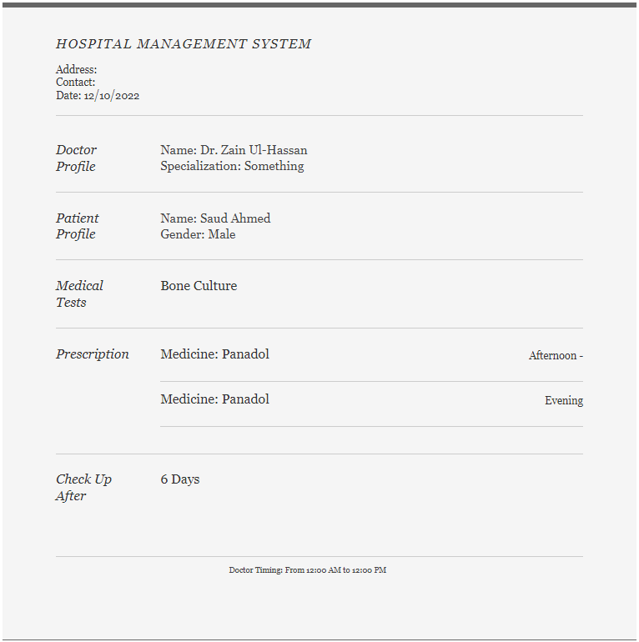

##### 6.3.3.3.3 Database Values

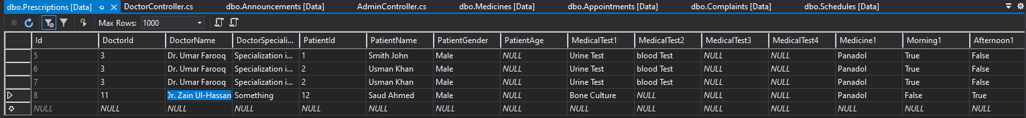

#### 6.3.3.4 Complaints

Here the patient can post their complaints in case of any contentions surrounding their visit to the site.

##### 6.3.3.4.1 List of Complaints

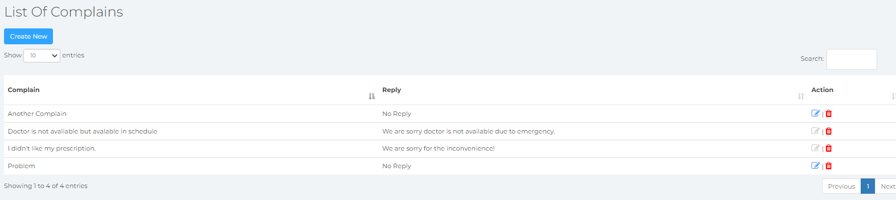

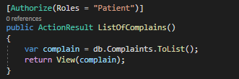

##### 6.3.3.4.2 Add Complaint

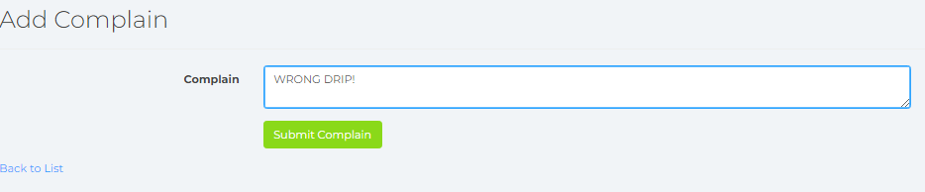

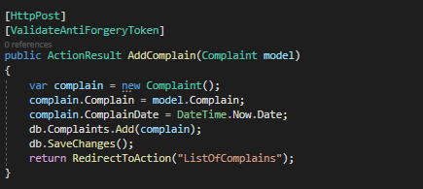

##### 6.3.3.4.3 Edit Complaint

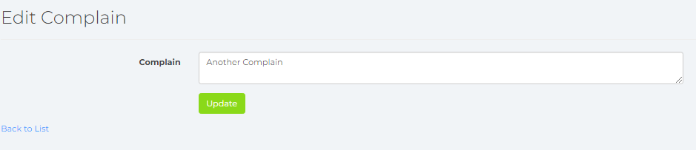

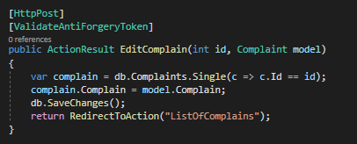

##### 6.3.3.4.4 Database Values

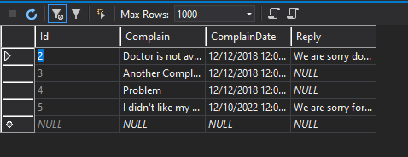

# 7 Middleware

## 7.1 Original WebService.asmx file

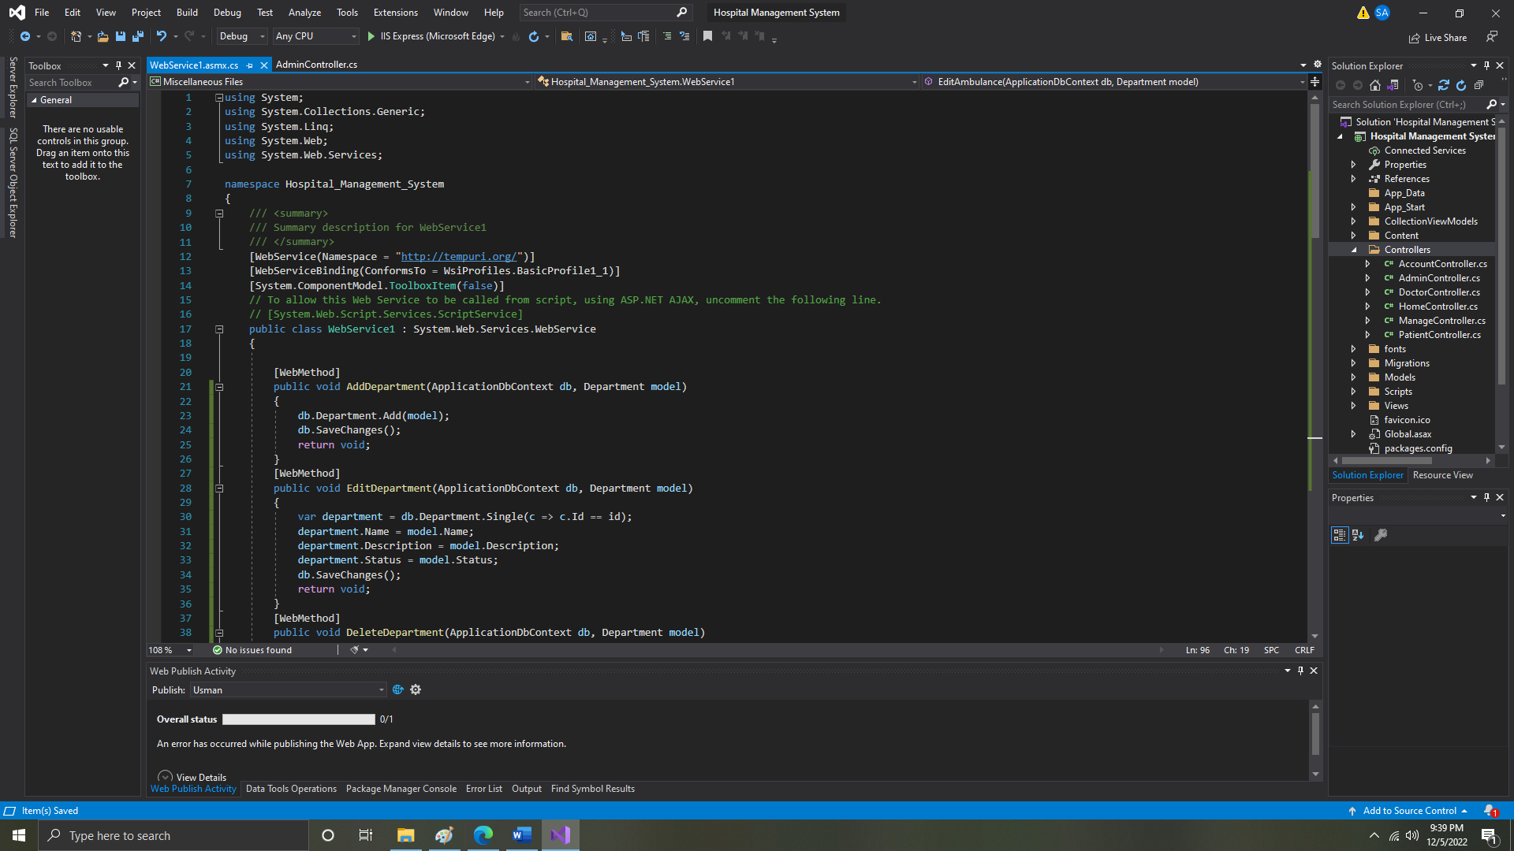

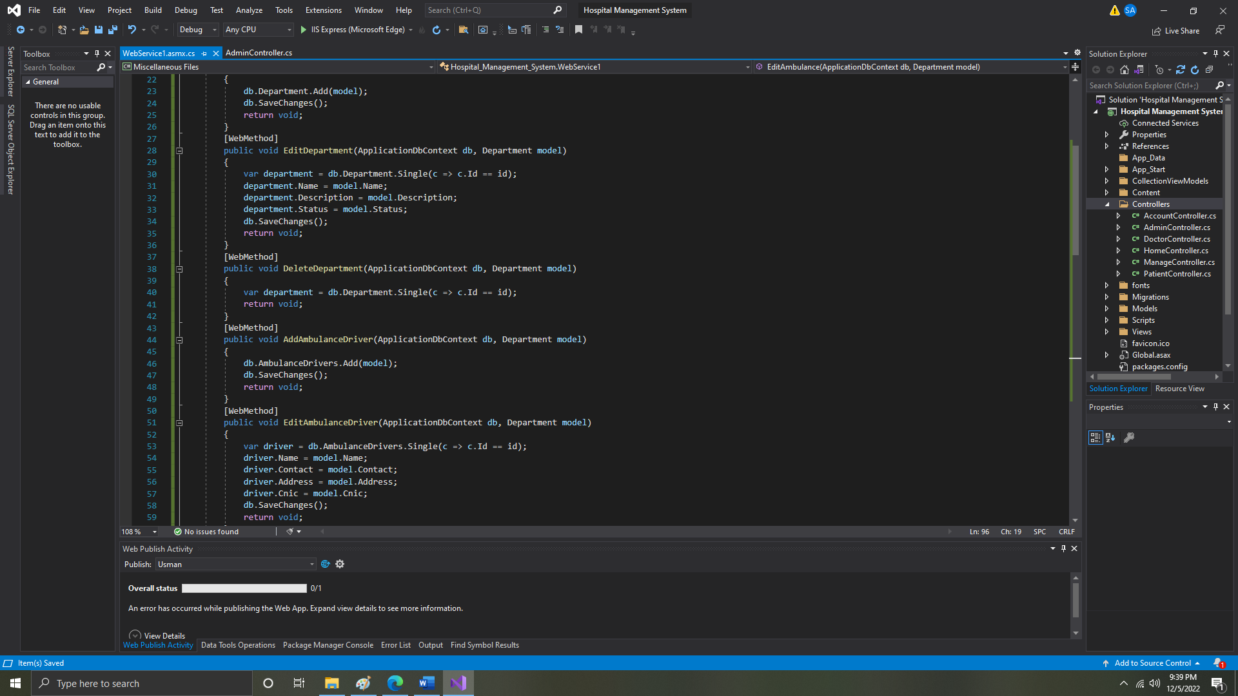

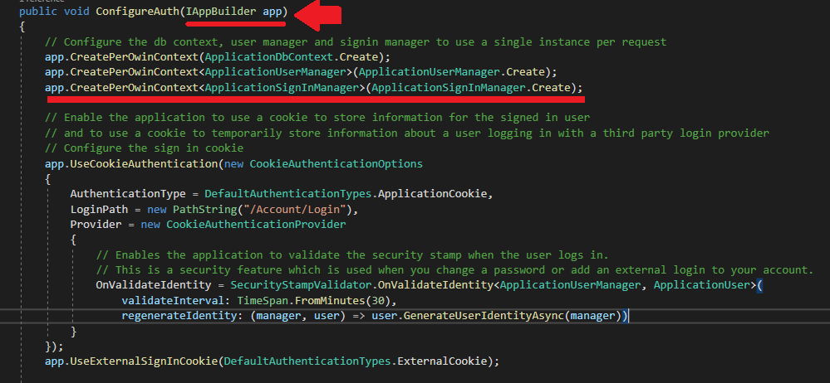

## 7.2 Understanding the Run Method

We used Run extension method to add middleware. The following is the signature of the Run method:

### 7.2.1 Method Signature Example#01

public static void Run(this IApplicationBuilder app, RequestDelegate handler)

The Run method is an extension method on IApplicationBuilder and accepts a parameter of RequestDelegate. The RequestDelegate is a delegate method which handles the request. The following is a RequestDelegate signature.

### 7.2.2 Method Signature Example#02

public delegate Task RequestDelegate(HttpContext context);

As you can see above, the Run method accepts a method as a parameter whose signature should match with RequestDelegate. Therefore, the method should accept the HttpContext parameter and return Task. So, you can either specify a lambda expression or specify a function in the Run method. The lambda expression specified in the Run method above is similar to the one in the example shown below.

public class Startup

{

public Startup()

{

}

public void Configure(IApplicationBuilder app, IHostingEnvironment env)

{

app.Run(MyMiddleware);

}

private Task MyMiddleware(HttpContext context)

{

return context.Response.WriteAsync("Hello World! ");

}

}

The above MyMiddleware function is not asynchronous and so will block the thread till the time it completes the execution. So, make it asynchronous by using async and await to improve performance and scalability.

// other code removed for clarity

public void Configure(IApplicationBuilder app, IHostingEnvironment env)

{

app.Run(MyMiddleware);

}

private async Task MyMiddleware(HttpContext context)

{

await context.Response.WriteAsync("Hello World! ");

}

Thus, the above code snippet is same as the one below.

app.Run(async context => await context.Response.WriteAsync("Hello World!") );

//or

app.Run(async (context) =>

{

await context.Response.WriteAsync("Hello World!");

});

So, in this way, we can configure middleware using Run method.

# 8 Conclusion

The Hospital Management System has been implemented with the Model-View-Controller (MVC) architecture on ASP.net, and it caters to many on-site hospital necessities such as medicine stock inventory, ambulance registry, management of user profiles for doctors and patients, setting on-site departments for doctor field expertise available, specialist approved prescription etc.

It fulfills all of the requirements that we have proposed and more-so it lives up to the core functionality that a good Hospital Management service would provide. This could present many opportunities to alleviate the struggle of having to keep physical documentations on patients that enter and leave the hospital daily and replaces it with a robust, efficient and present database that is flexible and integrates the structure into a virtual format well.

# 9 References

[1] Sarab, Sura. (2019). Hospital Management System. 10.13140/RG.2.2.35189.19686.

[2] Spamast-Malita, Iteit. (2018). Hospital Management System. 10.13140/RG.2.2.16459.28966.

[3] Kumar, Prem & Kosalram, Kalpana. (2013). E –Hospital Management & Hospital Information Systems – Changing Trends. International Journal of Information Engineering and Electronic Business. 1. 50-58. 10.5815/ijieeb.2013.01.06.

[4] Saimanoj, Kotapati & Poojitha, Grandhi & Dixit, Khushbu & Jayannavar, Laxmi. (2020). Hospital Management System using Web Technology.

[5] Garrido, T., Raymond, B., Jamieson, L., Liang, L., Wiesenthal, A., (2004). Making the business case for hospital information systems. Journal of Healthcare Finance, 31(2): 21–22.

[6] OECD report (2012). Competition in Hospital Services. Directorate for Financial and Enterprise Affairs Competition Committee. Competition Policy Roundtables, Unclassified document - DAF/COMP(2012)9. Accessed from: http://www.oecd.org/regreform/sectors/50527122.pdf